List of product-aggregator endpoints

1. Read CSV file

<http://localhost:8080/readCSV>

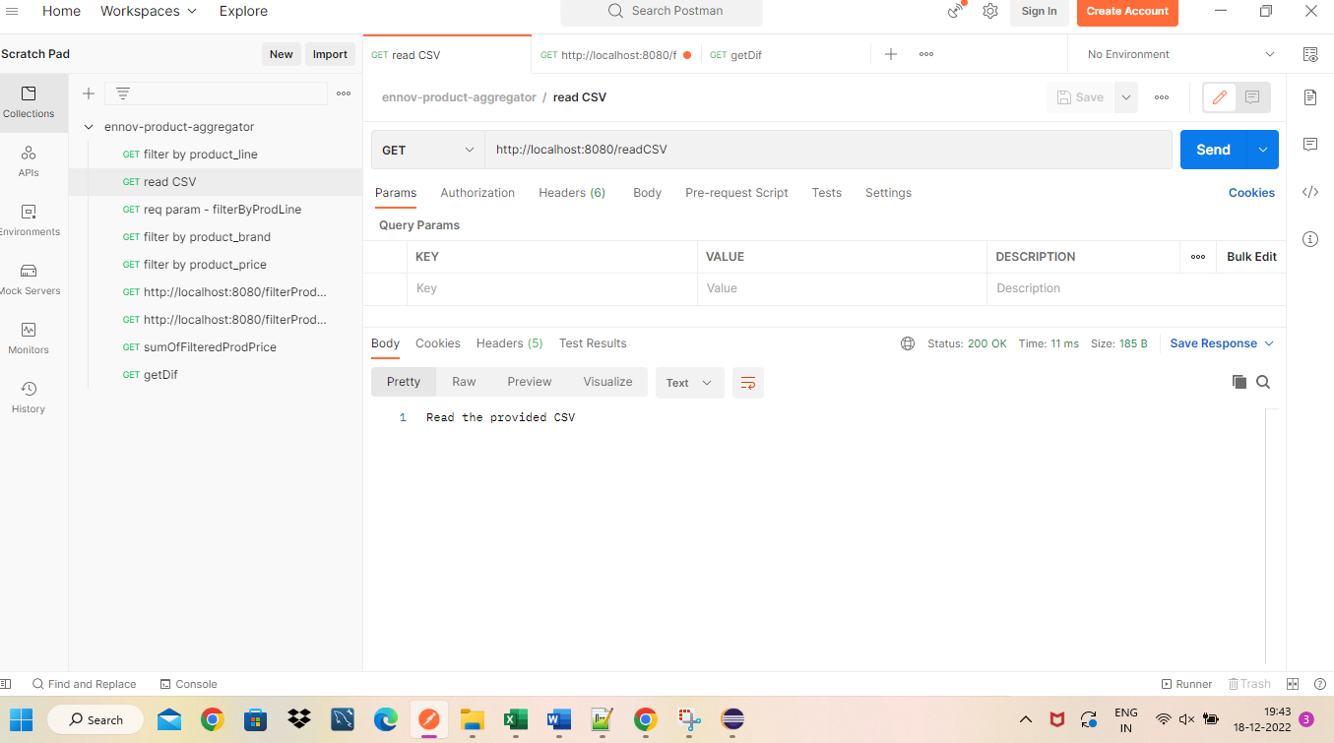

1. Case 1: if no filter selected

<http://localhost:8080/filterProducts>

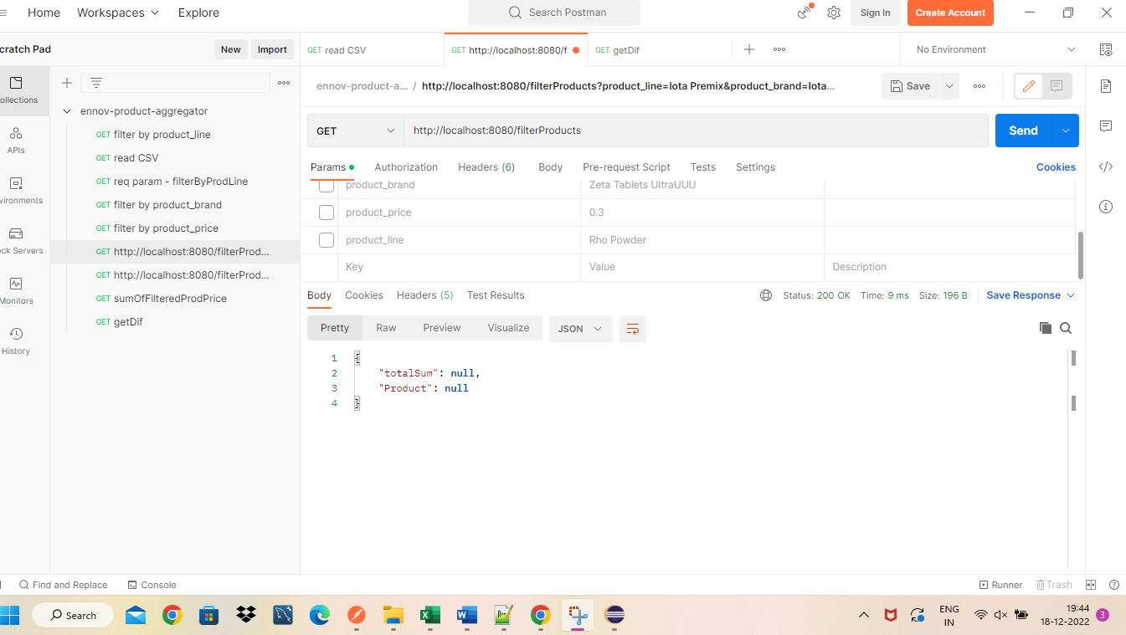

Case 2: User can select any of the filter, based on selected filter, response is given

1. Filter by product_line -

**http://localhost:8080/filterProducts?product_line=Rho Powder**

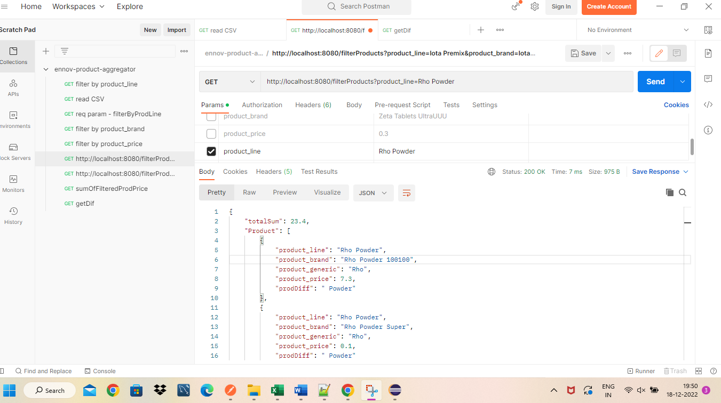

Response:

{

    "totalSum": 23.4,

    "Product": [

        {

            "product_line": "Rho Powder",

            "product_brand": "Rho Powder 100100",

            "product_generic": "Rho",

            "product_price": 7.3,

            "prodDiff": " Powder"

        },

        {

            "product_line": "Rho Powder",

            "product_brand": "Rho Powder Super",

            "product_generic": "Rho",

            "product_price": 0.1,

            "prodDiff": " Powder"

        },

        {

            "product_line": "Rho Powder",

            "product_brand": "Rho Powder Ultra",

            "product_generic": "Rho",

            "product_price": 4.3,

            "prodDiff": " Powder"

        },

        {

            "product_line": "Rho Powder",

            "product_brand": "Rho Powder 100100",

            "product_generic": "Rho",

            "product_price": 7.3,

            "prodDiff": " Powder"

        },

        {

            "product_line": "Rho Powder",

            "product_brand": "Rho Powder Super",

            "product_generic": "Rho",

            "product_price": 0.1,

            "prodDiff": " Powder"

        },

        {

            "product_line": "Rho Powder",

            "product_brand": "Rho Powder Ultra",

            "product_generic": "Rho",

            "product_price": 4.3,

            "prodDiff": " Powder"

        }

    ]

}

1. **Filter by product_brand –**

**http://localhost:8080/filterProducts?product_brand=Zeta Tablets UltraUUU**

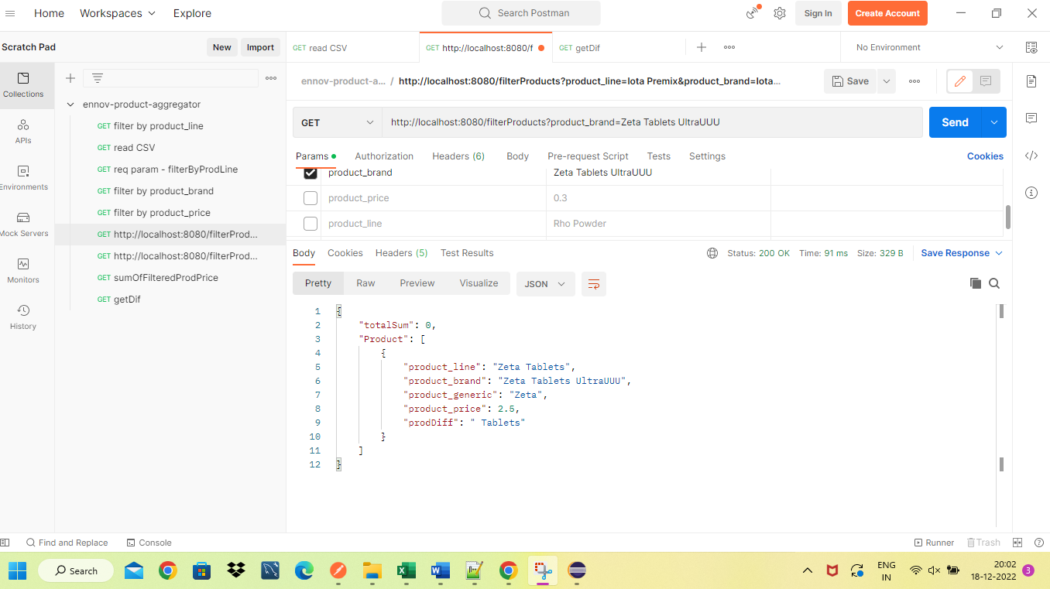

Response:

{

    "totalSum": 0,

    "Product": [

        {

            "product_line": "Zeta Tablets",

            "product_brand": "Zeta Tablets UltraUUU",

            "product_generic": "Zeta",

            "product_price": 2.5,

            "prodDiff": " Tablets"

        }

    ]

}

1. **Filter by product_price**

[**http://localhost:8080/filterProducts?product_price=0.3**](http://localhost:8080/filterProducts?product_price=0.3)

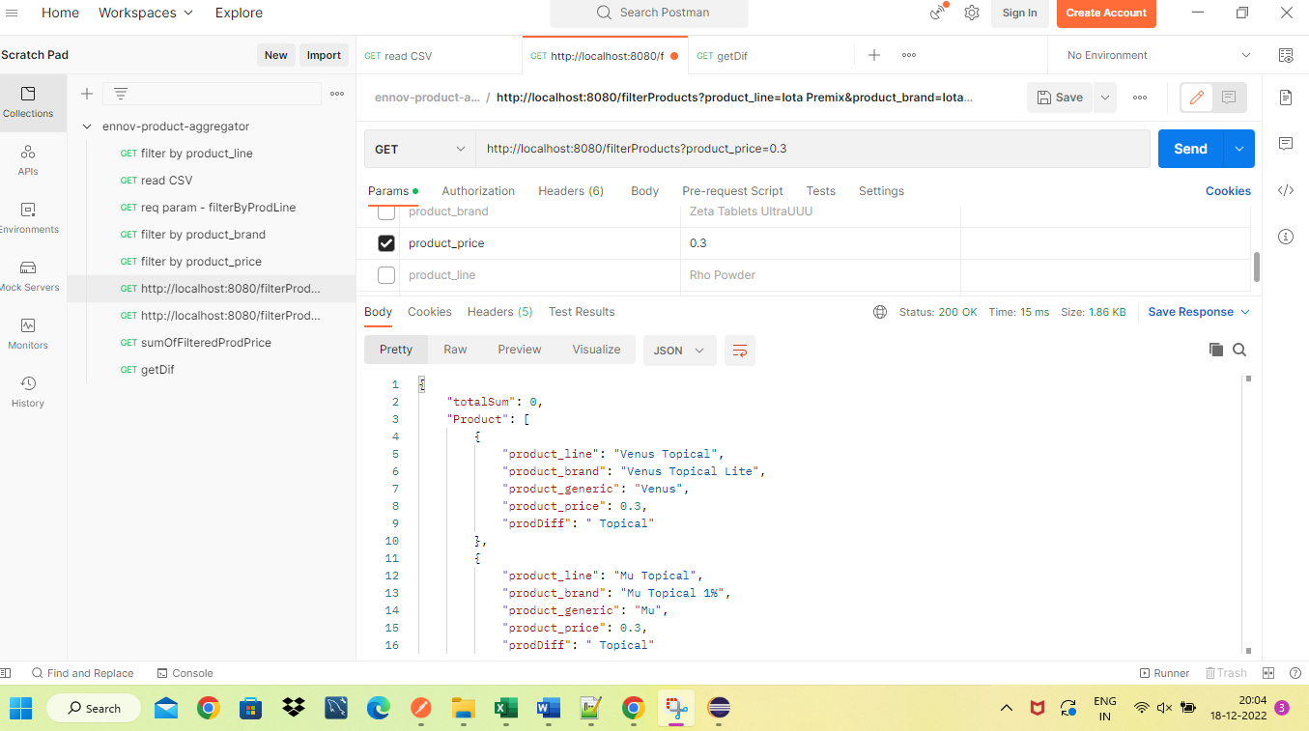

**Response:**

{

    "totalSum": 0,

    "Product": [

        {

            "product_line": "Venus Topical",

            "product_brand": "Venus Topical Lite",

            "product_generic": "Venus",

            "product_price": 0.3,

            "prodDiff": " Topical"

        },

        {

            "product_line": "Mu Topical",

            "product_brand": "Mu Topical 1%",

            "product_generic": "Mu",

            "product_price": 0.3,

            "prodDiff": " Topical"

        },

        {

            "product_line": "Mars Topical",

            "product_brand": "Mars Topical 1%",

            "product_generic": "Mars",

            "product_price": 0.3,

            "prodDiff": " Topical"

        },

        {

            "product_line": "Nu Powder",

            "product_brand": "Nu Powder Max",

            "product_generic": "Nu",

            "product_price": 0.3,

            "prodDiff": " Powder"

        },

        {

            "product_line": "Nu Powder",

            "product_brand": "Nu Powder Gold",

            "product_generic": "Nu",

            "product_price": 0.3,

            "prodDiff": " Powder"

        },

        {

            "product_line": "Mu Solution",

            "product_brand": "Mu Solution 100mg",

            "product_generic": "Mu",

            "product_price": 0.3,

            "prodDiff": " Solution"

        },

        {

            "product_line": "Beta Oral",

            "product_brand": "Beta Oral Gold",

            "product_generic": "Beta",

            "product_price": 0.3,

            "prodDiff": " Oral"

        },

        {

            "product_line": "Tau Bolus",

            "product_brand": "Tau Bolus Multi",

            "product_generic": "Tau",

            "product_price": 0.3,

            "prodDiff": " Bolus"

        },

        {

            "product_line": "Tau Capsules",

            "product_brand": "Tau Capsules 10mg",

            "product_generic": "Tau",

            "product_price": 0.3,

            "prodDiff": " Capsules"

        },

        {

            "product_line": "Lambda Tablets",

            "product_brand": "Lambda Tablets Mega",

            "product_generic": "Lambda",

            "product_price": 0.3,

            "prodDiff": " Tablets"

        },

        {

            "product_line": "Uranus Bolus",

            "product_brand": "Uranus Bolus Super",

            "product_generic": "Uranus",

            "product_price": 0.3,

            "prodDiff": " Bolus"

        },

        {

            "product_line": "Ksi Spray",

            "product_brand": "Ksi Spray 100",

            "product_generic": "Ksi",

            "product_price": 0.3,

            "prodDiff": " Spray"

        },

        {

            "product_line": "Omicron Solution",

            "product_brand": "Omicron Solution 10",

            "product_generic": "Omicron",

            "product_price": 0.3,

            "prodDiff": " Solution"

        }

    ]

}

1. **Filter by product_line, product_brand and product_price**
2. **If product not found with selected filter data**

**http://localhost:8080/filterProducts?product_brand=Zeta Tablets UltraUUU&product_price=0.3&product_line=Rho Powder**

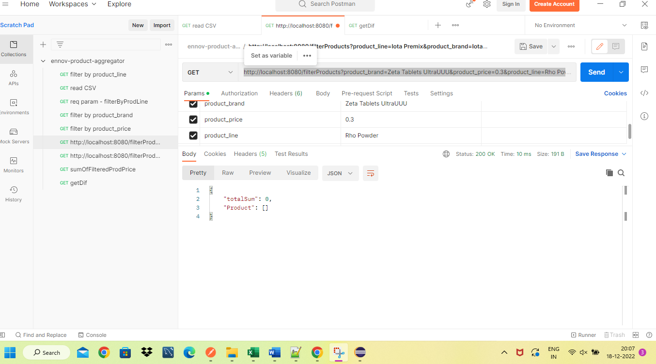

**Response:**

{

    "totalSum": 0,

    "Product": []

}

1. **With selected filter data - 3 filters selected are matched**

**http://localhost:8080/filterProducts?product_brand=Epsilon Capsules 25&product_price=6.4&product_line=Epsilon Capsules**

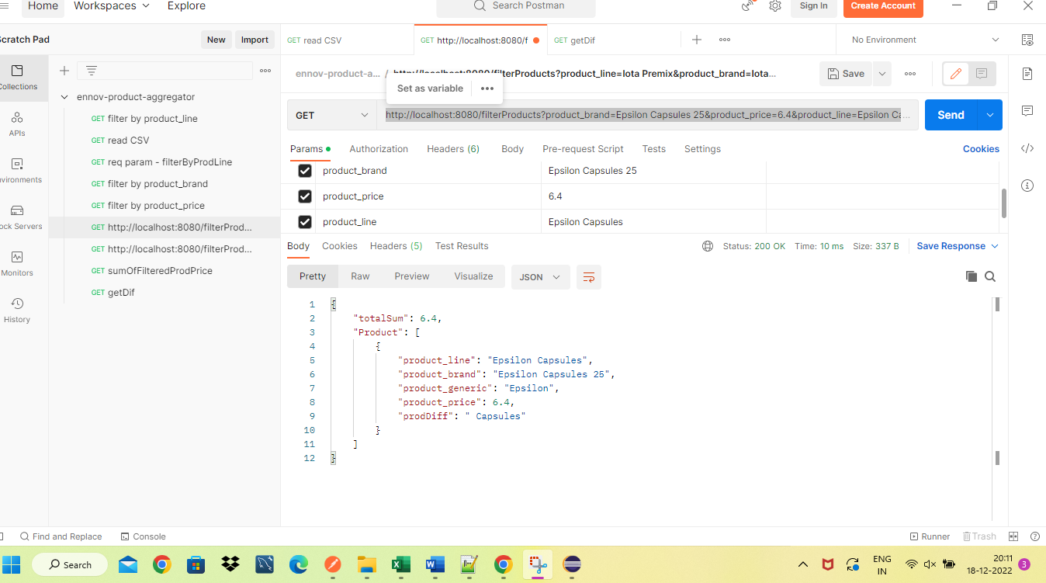

**Response:**

{

    "totalSum": 6.4,

    "Product": [

        {

            "product_line": "Epsilon Capsules",

            "product_brand": "Epsilon Capsules 25",

            "product_generic": "Epsilon",

            "product_price": 6.4,

            "prodDiff": " Capsules"

        }

    ]

}

1. **A ‘Product Aggregator’ application should return a list of differences between the ‘product generics’ and the ‘product lines’ for all products.**

[**http://localhost:8080/getDif**](http://localhost:8080/getDif)

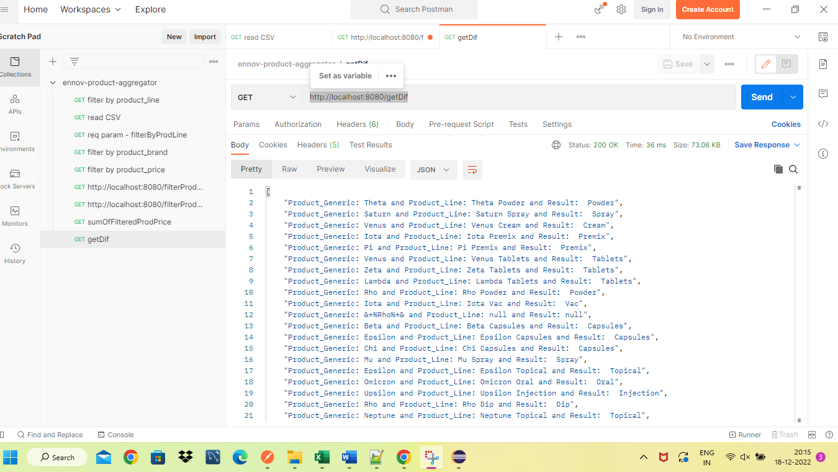

**Response:**

[

"Product_Generic: Theta and Product_Line: Theta Powder and Result: Powder",

"Product_Generic: Saturn and Product_Line: Saturn Spray and Result: Spray",

"Product_Generic: Venus and Product_Line: Venus Cream and Result: Cream",

"Product_Generic: Iota and Product_Line: Iota Premix and Result: Premix",

"Product_Generic: Pi and Product_Line: Pi Premix and Result: Premix",

"Product_Generic: Venus and Product_Line: Venus Tablets and Result: Tablets",

"Product_Generic: Zeta and Product_Line: Zeta Tablets and Result: Tablets",

"Product_Generic: Lambda and Product_Line: Lambda Tablets and Result: Tablets",

"Product_Generic: Rho and Product_Line: Rho Powder and Result: Powder",

"Product_Generic: Iota and Product_Line: Iota Vac and Result: Vac",

"Product_Generic: &*%Rho%*& and Product_Line: null and Result: null",

"Product_Generic: Beta and Product_Line: Beta Capsules and Result: Capsules",

"Product_Generic: Epsilon and Product_Line: Epsilon Capsules and Result: Capsules",

"Product_Generic: Chi and Product_Line: Chi Capsules and Result: Capsules",

"Product_Generic: Mu and Product_Line: Mu Spray and Result: Spray",

"Product_Generic: Epsilon and Product_Line: Epsilon Topical and Result: Topical",

"Product_Generic: Omicron and Product_Line: Omicron Oral and Result: Oral",

"Product_Generic: Upsilon and Product_Line: Upsilon Injection and Result: Injection",

"Product_Generic: Rho and Product_Line: Rho Dip and Result: Dip",

"Product_Generic: Neptune and Product_Line: Neptune Topical and Result: Topical",

"Product_Generic: Kappa and Product_Line: Kappa Vac and Result: Vac",

"Product_Generic: Phi and Product_Line: Phi Topical and Result: Topical",

"Product_Generic: Saturn and Product_Line: Saturn Premix and Result: Premix",

"Product_Generic: Venus and Product_Line: Venus Topical and Result: Topical",

"Product_Generic: Mercury and Product_Line: Mercury Spray and Result: Spray",

"Product_Generic: Mu and Product_Line: Mu Spray and Result: Spray",

"Product_Generic: Mercury and Product_Line: Mercury Spray and Result: Spray",

"Product_Generic: Neptune and Product_Line: Neptune Tablets and Result: Tablets",

"Product_Generic: Zeta and Product_Line: Zeta Spray and Result: Spray",

"Product_Generic: Eta and Product_Line: Eta Spray and Result: Spray",

"Product_Generic: Iota and Product_Line: Iota Solution and Result: Solution",

"Product_Generic: Omega and Product_Line: Omega Vac and Result: Vac",

"Product_Generic: Beta and Product_Line: Beta Oral and Result: Oral",

"Product_Generic: Kappa and Product_Line: Kappa Capsules and Result: Capsules",

"Product_Generic: Neptune and Product_Line: Neptune Dip and Result: Dip",

"Product_Generic: Ksi and Product_Line: Ksi Capsules and Result: Capsules",

"Product_Generic: Psi and Product_Line: Psi Cream and Result: Cream",

"Product_Generic: Lambda and Product_Line: Lambda Bolus and Result: Bolus",

"Product_Generic: Eta and Product_Line: Eta Spray and Result: Spray",

"Product_Generic: Beta and Product_Line: Beta Spray and Result: Spray",

"Product_Generic: Uranus and Product_Line: Uranus Spray and Result: Spray",

"Product_Generic: Earth and Product_Line: Earth Spray and Result: Spray",

"Product_Generic: Zeta and Product_Line: Zeta Dip and Result: Dip",

"Product_Generic: Rho and Product_Line: Rho Bolus and Result: Bolus",

"Product_Generic: Mars and Product_Line: Mars Bolus and Result: Bolus",

"Product_Generic: Pi and Product_Line: Pi Spray and Result: Spray",

"Product_Generic: Zeta and Product_Line: Zeta Oral and Result: Oral",

"Product_Generic: Ksi and Product_Line: Ksi Topical and Result: Topical",

"Product_Generic: Omicron and Product_Line: Omicron Capsules and Result: Capsules",

"Product_Generic: Upsilon and Product_Line: Upsilon Oral and Result: Oral",

"Product_Generic: Mu and Product_Line: Mu Spray and Result: Spray",

"Product_Generic: Sigma and Product_Line: Sigma Spray and Result: Spray",

"Product_Generic: Epsilon and Product_Line: Epsilon Topical and Result: Topical",

"Product_Generic: Mu and Product_Line: Mu Cream and Result: Cream",

"Product_Generic: Omega and Product_Line: Omega Oral and Result: Oral",

"Product_Generic: Epsilon and Product_Line: Epsilon Powder and Result: Powder",

"Product_Generic: Rho and Product_Line: Rho Spray and Result: Spray",

"Product_Generic: Mars and Product_Line: Mars Spray and Result: Spray",

"Product_Generic: Psi and Product_Line: Psi Cream and Result: Cream",

"Product_Generic: Upsilon and Product_Line: Upsilon Topical and Result: Topical",

"Product_Generic: Zeta and Product_Line: Zeta Spray and Result: Spray",

"Product_Generic: Nu and Product_Line: Nu Vac and Result: Vac",

"Product_Generic: Jupiter and Product_Line: Jupiter Injection and Result: Injection",

"Product_Generic: Mu and Product_Line: Mu Injection and Result: Injection",

"Product_Generic: Beta and Product_Line: Beta Powder and Result: Powder",

"Product_Generic: Alpha and Product_Line: Alpha Capsules and Result: Capsules",

"Product_Generic: Venus and Product_Line: Venus Dip and Result: Dip",

"Product_Generic: Theta and Product_Line: Theta Premix and Result: Premix",

"Product_Generic: Upsilon and Product_Line: Upsilon Premix and Result: Premix",

"Product_Generic: Iota and Product_Line: Iota Spray and Result: Spray",

"Product_Generic: Phi and Product_Line: Phi Spray and Result: Spray",

"Product_Generic: Omega and Product_Line: Omega Bolus and Result: Bolus",

"Product_Generic: Iota and Product_Line: Iota Cream and Result: Cream",

"Product_Generic: Uranus and Product_Line: Uranus Dip and Result: Dip",

"Product_Generic: Kappa and Product_Line: Kappa Solution and Result: Solution",

"Product_Generic: Mu and Product_Line: Mu Vac and Result: Vac",

"Product_Generic: Omicron and Product_Line: Omicron Spray and Result: Spray",

"Product_Generic: Iota and Product_Line: Iota Solution and Result: Solution",

"Product_Generic: Mercury and Product_Line: Mercury Spray and Result: Spray",

"Product_Generic: Uranus and Product_Line: Uranus Spray and Result: Spray",

"Product_Generic: Pi and Product_Line: Pi Oral and Result: Oral",

"Product_Generic: Alpha and Product_Line: Alpha Vac and Result: Vac",

"Product_Generic: Iota and Product_Line: Iota Solution and Result: Solution",

"Product_Generic: Delta and Product_Line: Delta Cream and Result: Cream",

"Product_Generic: Beta and Product_Line: Beta Premix and Result: Premix",

"Product_Generic: Beta and Product_Line: Beta Powder and Result: Powder",

"Product_Generic: Alpha and Product_Line: Alpha Oral and Result: Oral",

"Product_Generic: Mu and Product_Line: Mu Vac and Result: Vac",

"Product_Generic: Chi and Product_Line: Chi Cream and Result: Cream",

"Product_Generic: Alpha and Product_Line: Alpha Dip and Result: Dip",

"Product_Generic: Zeta and Product_Line: Zeta Vac and Result: Vac",

"Product_Generic: Chi and Product_Line: Chi Powder and Result: Powder",

"Product_Generic: Saturn and Product_Line: Saturn Vac and Result: Vac",

"Product_Generic: Neptune and Product_Line: Neptune Injection and Result: Injection",

"Product_Generic: Jupiter and Product_Line: Jupiter Oral and Result: Oral",

"Product_Generic: Kappa and Product_Line: Kappa Topical and Result: Topical",

"Product_Generic: Ksi and Product_Line: Ksi Oral and Result: Oral",

"Product_Generic: Omicron and Product_Line: Omicron Spray and Result: Spray",

"Product_Generic: Eta and Product_Line: Eta Solution and Result: Solution",

"Product_Generic: Alpha and Product_Line: Alpha Bolus and Result: Bolus",

"Product_Generic: Phi and Product_Line: Phi Solution and Result: Solution",

"Product_Generic: Lambda and Product_Line: Lambda Premix and Result: Premix",

"Product_Generic: Delta and Product_Line: Delta Tablets and Result: Tablets",

"Product_Generic: Delta and Product_Line: Delta Dip and Result: Dip",

"Product_Generic: Kappa and Product_Line: Kappa Capsules and Result: Capsules",

"Product_Generic: Gamma and Product_Line: Gamma Solution and Result: Solution",

"Product_Generic: Uranus and Product_Line: Uranus Injection and Result: Injection",

"Product_Generic: Beta and Product_Line: Beta Bolus and Result: Bolus",

"Product_Generic: Venus and Product_Line: Venus Cream and Result: Cream",

"Product_Generic: Tau and Product_Line: Tau Powder and Result: Powder",

"Product_Generic: Psi and Product_Line: Psi Tablets and Result: Tablets",

"Product_Generic: Saturn and Product_Line: Saturn Oral and Result: Oral",

"Product_Generic: Phi and Product_Line: Phi Oral and Result: Oral",

"Product_Generic: Earth and Product_Line: Earth Vac and Result: Vac",

"Product_Generic: Omega and Product_Line: Omega Topical and Result: Topical",

"Product_Generic: Kappa and Product_Line: Kappa Premix and Result: Premix",

"Product_Generic: Theta and Product_Line: Theta Tablets and Result: Tablets",

"Product_Generic: Lambda and Product_Line: Lambda Oral and Result: Oral",

"Product_Generic: Venus and Product_Line: Venus Injection and Result: Injection",

"Product_Generic: Omega and Product_Line: Omega Solution and Result: Solution",

"Product_Generic: Uranus and Product_Line: Uranus Vac and Result: Vac",

"Product_Generic: Nu and Product_Line: Nu Injection and Result: Injection",

"Product_Generic: Zeta and Product_Line: Zeta Capsules and Result: Capsules",

"Product_Generic: Chi and Product_Line: Chi Premix and Result: Premix",

"Product_Generic: Upsilon and Product_Line: Upsilon Dip and Result: Dip",

"Product_Generic: Zeta and Product_Line: Zeta Premix and Result: Premix",

"Product_Generic: Rho and Product_Line: Rho Injection and Result: Injection",

"Product_Generic: Omega and Product_Line: Omega Injection and Result: Injection",

"Product_Generic: Chi and Product_Line: Chi Cream and Result: Cream",

"Product_Generic: Jupiter and Product_Line: Jupiter Dip and Result: Dip",

"Product_Generic: Mu and Product_Line: Mu Topical and Result: Topical",

"Product_Generic: Tau and Product_Line: Tau Oral and Result: Oral",

"Product_Generic: Earth and Product_Line: Earth Topical and Result: Topical",

"Product_Generic: Alpha and Product_Line: Alpha Vac and Result: Vac",

"Product_Generic: Sigma and Product_Line: Sigma Dip and Result: Dip",

"Product_Generic: Jupiter and Product_Line: Jupiter Premix and Result: Premix",

"Product_Generic: Delta and Product_Line: Delta Bolus and Result: Bolus",

"Product_Generic: Iota and Product_Line: Iota Vac and Result: Vac",

"Product_Generic: Omicron and Product_Line: Omicron Tablets and Result: Tablets",

"Product_Generic: Rho and Product_Line: Rho Bolus and Result: Bolus",

"Product_Generic: Eta and Product_Line: Eta Solution and Result: Solution",

"Product_Generic: Eta and Product_Line: Eta Capsules and Result: Capsules",

"Product_Generic: Psi and Product_Line: Psi Capsules and Result: Capsules",

"Product_Generic: Eta and Product_Line: Eta Bolus and Result: Bolus",

"Product_Generic: Earth and Product_Line: Earth Premix and Result: Premix",

"Product_Generic: Alpha and Product_Line: Alpha Bolus and Result: Bolus",

"Product_Generic: Eta and Product_Line: Eta Cream and Result: Cream",

"Product_Generic: Jupiter and Product_Line: Jupiter Cream and Result: Cream",

"Product_Generic: Mars and Product_Line: Mars Spray and Result: Spray",

"Product_Generic: Phi and Product_Line: Phi Oral and Result: Oral",

"Product_Generic: Mars and Product_Line: Mars Topical and Result: Topical",

"Product_Generic: Gamma and Product_Line: Gamma Tablets and Result: Tablets",

"Product_Generic: Gamma and Product_Line: Gamma Injection and Result: Injection",

"Product_Generic: Lambda and Product_Line: Lambda Solution and Result: Solution",

"Product_Generic: Phi and Product_Line: Phi Spray and Result: Spray",

"Product_Generic: Uranus and Product_Line: Uranus Powder and Result: Powder",

"Product_Generic: Tau and Product_Line: Tau Topical and Result: Topical",

"Product_Generic: Jupiter and Product_Line: Jupiter Premix and Result: Premix",

"Product_Generic: Chi and Product_Line: Chi Tablets and Result: Tablets",

"Product_Generic: Alpha and Product_Line: Alpha Cream and Result: Cream",

"Product_Generic: Saturn and Product_Line: Saturn Premix and Result: Premix",

"Product_Generic: Epsilon and Product_Line: Epsilon Powder and Result: Powder",

"Product_Generic: Mars and Product_Line: Mars Spray and Result: Spray",

"Product_Generic: Pi and Product_Line: Pi Spray and Result: Spray",

"Product_Generic: Omicron and Product_Line: Omicron Capsules and Result: Capsules",

"Product_Generic: Eta and Product_Line: Eta Solution and Result: Solution",

"Product_Generic: Delta and Product_Line: Delta Powder and Result: Powder",

"Product_Generic: Ksi and Product_Line: Ksi Premix and Result: Premix",

"Product_Generic: Earth and Product_Line: Earth Spray and Result: Spray",

"Product_Generic: Omega and Product_Line: Omega Injection and Result: Injection",

"Product_Generic: Jupiter and Product_Line: Jupiter Capsules and Result: Capsules",

"Product_Generic: Venus and Product_Line: Venus Bolus and Result: Bolus",

"Product_Generic: Uranus and Product_Line: Uranus Bolus and Result: Bolus",

"Product_Generic: Gamma and Product_Line: Gamma Cream and Result: Cream",

"Product_Generic: Phi and Product_Line: Phi Spray and Result: Spray",

"Product_Generic: Mu and Product_Line: Mu Injection and Result: Injection",

"Product_Generic: Delta and Product_Line: Delta Oral and Result: Oral",

"Product_Generic: Neptune and Product_Line: Neptune Capsules and Result: Capsules",

"Product_Generic: Zeta and Product_Line: Zeta Spray and Result: Spray",

"Product_Generic: Chi and Product_Line: Chi Powder and Result: Powder",

"Product_Generic: Mercury and Product_Line: Mercury Vac and Result: Vac",

"Product_Generic: Mu and Product_Line: Mu Injection and Result: Injection",

"Product_Generic: Alpha and Product_Line: Alpha Powder and Result: Powder",

"Product_Generic: Upsilon and Product_Line: Upsilon Injection and Result: Injection",

"Product_Generic: Earth and Product_Line: Earth Dip and Result: Dip",

"Product_Generic: Mars and Product_Line: Mars Vac and Result: Vac",

"Product_Generic: Upsilon and Product_Line: Upsilon Premix and Result: Premix",

"Product_Generic: Delta and Product_Line: Delta Powder and Result: Powder",

"Product_Generic: Neptune and Product_Line: Neptune Solution and Result: Solution",

"Product_Generic: Alpha and Product_Line: Alpha Powder and Result: Powder",

"Product_Generic: Eta and Product_Line: Eta Injection and Result: Injection",

"Product_Generic: Mu and Product_Line: Mu Vac and Result: Vac",

"Product_Generic: Iota and Product_Line: Iota Spray and Result: Spray",

"Product_Generic: Pi and Product_Line: Pi Spray and Result: Spray",

"Product_Generic: Mercury and Product_Line: Mercury Vac and Result: Vac",

"Product_Generic: Earth and Product_Line: Earth Bolus and Result: Bolus",

"Product_Generic: Mu and Product_Line: Mu Capsules and Result: Capsules",

"Product_Generic: Iota and Product_Line: Iota Dip and Result: Dip",

"Product_Generic: Kappa and Product_Line: Kappa Capsules and Result: Capsules",

"Product_Generic: Chi and Product_Line: Chi Injection and Result: Injection",

"Product_Generic: Gamma and Product_Line: Gamma Injection and Result: Injection",

"Product_Generic: Upsilon and Product_Line: Upsilon Dip and Result: Dip",

"Product_Generic: Lambda and Product_Line: Lambda Spray and Result: Spray",

"Product_Generic: Pi and Product_Line: Pi Premix and Result: Premix",

"Product_Generic: Theta and Product_Line: Theta Premix and Result: Premix",

"Product_Generic: Epsilon and Product_Line: Epsilon Oral and Result: Oral",

"Product_Generic: Iota and Product_Line: Iota Tablets and Result: Tablets",

"Product_Generic: Psi and Product_Line: Psi Tablets and Result: Tablets",

"Product_Generic: Earth and Product_Line: Earth Tablets and Result: Tablets",

"Product_Generic: Gamma and Product_Line: Gamma Capsules and Result: Capsules",

"Product_Generic: Omicron and Product_Line: Omicron Dip and Result: Dip",

"Product_Generic: Chi and Product_Line: Chi Topical and Result: Topical",

"Product_Generic: Mu and Product_Line: Mu Injection and Result: Injection",

"Product_Generic: Omicron and Product_Line: Omicron Oral and Result: Oral",

"Product_Generic: Omega and Product_Line: Omega Cream and Result: Cream",

"Product_Generic: Uranus and Product_Line: Uranus Cream and Result: Cream",

"Product_Generic: Lambda and Product_Line: Lambda Injection and Result: Injection",

"Product_Generic: Nu and Product_Line: Nu Powder and Result: Powder",

"Product_Generic: Zeta and Product_Line: Zeta Injection and Result: Injection",

"Product_Generic: Gamma and Product_Line: Gamma Solution and Result: Solution",

"Product_Generic: Delta and Product_Line: Delta Capsules and Result: Capsules",

"Product_Generic: Omicron and Product_Line: Omicron Premix and Result: Premix",

"Product_Generic: Omicron and Product_Line: Omicron Dip and Result: Dip",

"Product_Generic: Alpha and Product_Line: Alpha Tablets and Result: Tablets",

"Product_Generic: Gamma and Product_Line: Gamma Premix and Result: Premix",

"Product_Generic: Omega and Product_Line: Omega Topical and Result: Topical",

"Product_Generic: Iota and Product_Line: Iota Injection and Result: Injection",

"Product_Generic: Neptune and Product_Line: Neptune Injection and Result: Injection",

"Product_Generic: Nu and Product_Line: Nu Powder and Result: Powder",

"Product_Generic: Epsilon and Product_Line: Epsilon Dip and Result: Dip",

"Product_Generic: Mars and Product_Line: Mars Spray and Result: Spray",

"Product_Generic: Mercury and Product_Line: Mercury Dip and Result: Dip",

"Product_Generic: Epsilon and Product_Line: Epsilon Premix and Result: Premix",

"Product_Generic: Earth and Product_Line: Earth Spray and Result: Spray",

"Product_Generic: Mu and Product_Line: Mu Solution and Result: Solution",

"Product_Generic: Sigma and Product_Line: Sigma Oral and Result: Oral",

"Product_Generic: Saturn and Product_Line: Saturn Topical and Result: Topical",

"Product_Generic: Venus and Product_Line: Venus Injection and Result: Injection",

"Product_Generic: Iota and Product_Line: Iota Capsules and Result: Capsules",

"Product_Generic: Delta and Product_Line: Delta Topical and Result: Topical",

"Product_Generic: Gamma and Product_Line: Gamma Injection and Result: Injection",

"Product_Generic: Psi and Product_Line: Psi Capsules and Result: Capsules",

"Product_Generic: Chi and Product_Line: Chi Premix and Result: Premix",

"Product_Generic: Eta and Product_Line: Eta Premix and Result: Premix",

"Product_Generic: Nu and Product_Line: Nu Cream and Result: Cream",

"Product_Generic: Iota and Product_Line: Iota Solution and Result: Solution",

"Product_Generic: Beta and Product_Line: Beta Oral and Result: Oral",

"Product_Generic: Lambda and Product_Line: Lambda Capsules and Result: Capsules",

"Product_Generic: Omega and Product_Line: Omega Spray and Result: Spray",

"Product_Generic: Jupiter and Product_Line: Jupiter Premix and Result: Premix",

"Product_Generic: Ksi and Product_Line: Ksi Dip and Result: Dip",

"Product_Generic: Neptune and Product_Line: Neptune Cream and Result: Cream",

"Product_Generic: Iota and Product_Line: Iota Powder and Result: Powder",

"Product_Generic: Venus and Product_Line: Venus Dip and Result: Dip",

"Product_Generic: Beta and Product_Line: Beta Premix and Result: Premix",

"Product_Generic: Mercury and Product_Line: Mercury Dip and Result: Dip",

"Product_Generic: Uranus and Product_Line: Uranus Tablets and Result: Tablets",

"Product_Generic: Earth and Product_Line: Earth Cream and Result: Cream",

"Product_Generic: Pi and Product_Line: Pi Topical and Result: Topical",

"Product_Generic: Uranus and Product_Line: Uranus Bolus and Result: Bolus",

"Product_Generic: Kappa and Product_Line: Kappa Bolus and Result: Bolus",

"Product_Generic: Neptune and Product_Line: Neptune Injection and Result: Injection",

"Product_Generic: Epsilon and Product_Line: Epsilon Powder and Result: Powder",

"Product_Generic: Kappa and Product_Line: Kappa Premix and Result: Premix",

"Product_Generic: Eta and Product_Line: Eta Premix and Result: Premix",

"Product_Generic: Beta and Product_Line: Beta Solution and Result: Solution",

"Product_Generic: Chi and Product_Line: Chi Topical and Result: Topical",

"Product_Generic: Nu and Product_Line: Nu Oral and Result: Oral",

"Product_Generic: Jupiter and Product_Line: Jupiter Topical and Result: Topical",

"Product_Generic: Tau and Product_Line: Tau Tablets and Result: Tablets",

"Product_Generic: Theta and Product_Line: Theta Dip and Result: Dip",

"Product_Generic: Upsilon and Product_Line: Upsilon Spray and Result: Spray",

"Product_Generic: Omicron and Product_Line: Omicron Solution and Result: Solution",

"Product_Generic: Saturn and Product_Line: Saturn Oral and Result: Oral",

"Product_Generic: Chi and Product_Line: Chi Capsules and Result: Capsules",

"Product_Generic: Gamma and Product_Line: Gamma Injection and Result: Injection",

"Product_Generic: Epsilon and Product_Line: Epsilon Topical and Result: Topical",

"Product_Generic: Tau and Product_Line: Tau Dip and Result: Dip",

"Product_Generic: Saturn and Product_Line: Saturn Vac and Result: Vac",

"Product_Generic: Theta and Product_Line: Theta Cream and Result: Cream",

"Product_Generic: Pi and Product_Line: Pi Capsules and Result: Capsules",

"Product_Generic: Beta and Product_Line: Beta Cream and Result: Cream",

"Product_Generic: Phi and Product_Line: Phi Spray and Result: Spray",

"Product_Generic: Jupiter Jupiter and Product_Line: Jupiter Premix and Result: Premix",

"Product_Generic: Phi and Product_Line: Phi Vac and Result: Vac",

"Product_Generic: Venus and Product_Line: Venus Injection and Result: Injection",

"Product_Generic: Alpha and Product_Line: Alpha Spray and Result: Spray",

"Product_Generic: Delta and Product_Line: Delta Dip and Result: Dip",

"Product_Generic: Gamma and Product_Line: Gamma Capsules and Result: Capsules",

"Product_Generic: Theta and Product_Line: Theta Dip and Result: Dip",

"Product_Generic: Delta and Product_Line: Delta Spray and Result: Spray",

"Product_Generic: Iota and Product_Line: Iota Vac and Result: Vac",

"Product_Generic: Gamma and Product_Line: Gamma Oral and Result: Oral",

"Product_Generic: Ksi and Product_Line: Ksi Powder and Result: Powder",

"Product_Generic: Jupiter and Product_Line: Jupiter Capsules and Result: Capsules",

"Product_Generic: Sigma and Product_Line: Sigma Injection and Result: Injection",

"Product_Generic: Sigma and Product_Line: Sigma Injection and Result: Injection",

"Product_Generic: Upsilon and Product_Line: Upsilon Capsules and Result: Capsules",

"Product_Generic: Saturn and Product_Line: Saturn Solution and Result: Solution",

"Product_Generic: Iota and Product_Line: Iota Dip and Result: Dip",

"Product_Generic: Earth and Product_Line: Earth Spray and Result: Spray",

"Product_Generic: Nu and Product_Line: Nu Tablets and Result: Tablets",

"Product_Generic: Theta and Product_Line: Theta Capsules and Result: Capsules",

"Product_Generic: Iota and Product_Line: Iota Dip and Result: Dip",

"Product_Generic: Sigma Sigma and Product_Line: Sigma Vac and Result: Vac",

"Product_Generic: Eta and Product_Line: Eta Tablets and Result: Tablets",

"Product_Generic: Iota and Product_Line: Iota Tablets and Result: Tablets",

"Product_Generic: Mercury and Product_Line: Mercury Spray and Result: Spray",

"Product_Generic: Beta and Product_Line: Beta Powder and Result: Powder",

"Product_Generic: Saturn and Product_Line: Saturn Capsules and Result: Capsules",

"Product_Generic: Mu and Product_Line: Mu Bolus and Result: Bolus",

"Product_Generic: Epsilon and Product_Line: Epsilon Solution and Result: Solution",

"Product_Generic: Phi and Product_Line: Phi Injection and Result: Injection",

"Product_Generic: Lambda and Product_Line: Lambda Powder and Result: Powder",

"Product_Generic: Jupiter and Product_Line: Jupiter Tablets and Result: Tablets",

"Product_Generic: Sigma and Product_Line: Sigma Tablets and Result: Tablets",

"Product_Generic: Neptune and Product_Line: Neptune Powder and Result: Powder",

"Product_Generic: Kappa and Product_Line: Kappa Capsules and Result: Capsules",

"Product_Generic: Neptune and Product_Line: Neptune Oral and Result: Oral",

"Product_Generic: Kappa and Product_Line: Kappa Capsules and Result: Capsules",

"Product_Generic: Iota and Product_Line: Iota Dip and Result: Dip",

"Product_Generic: Upsilon and Product_Line: Upsilon Capsules and Result: Capsules",

"Product_Generic: Tau and Product_Line: Tau Injection and Result: Injection",

"Product_Generic: Saturn and Product_Line: Saturn Solution and Result: Solution",

"Product_Generic: Tau and Product_Line: Tau Solution and Result: Solution",

"Product_Generic: Omega and Product_Line: Omega Capsules and Result: Capsules",

"Product_Generic: Uranus and Product_Line: Uranus Powder and Result: Powder",

"Product_Generic: Uranus and Product_Line: Uranus Solution and Result: Solution",

"Product_Generic: Pi and Product_Line: Pi Solution and Result: Solution",

"Product_Generic: Lambda and Product_Line: Lambda Dip and Result: Dip",

"Product_Generic: Upsilon and Product_Line: Upsilon Capsules and Result: Capsules",

"Product_Generic: Mars and Product_Line: Mars Solution and Result: Solution",

"Product_Generic: Delta and Product_Line: Delta Spray and Result: Spray",

"Product_Generic: Sigma and Product_Line: Sigma Vac and Result: Vac",

"Product_Generic: Gamma and Product_Line: Gamma Vac and Result: Vac",

"Product_Generic: Saturn and Product_Line: Saturn Injection and Result: Injection",

"Product_Generic: Iota and Product_Line: Iota Spray and Result: Spray",

"Product_Generic: Saturn and Product_Line: Saturn Injection and Result: Injection",

"Product_Generic: Kappa and Product_Line: Kappa Spray and Result: Spray",

"Product_Generic: Saturn and Product_Line: Saturn Premix and Result: Premix",

"Product_Generic: Alpha and Product_Line: Alpha Capsules and Result: Capsules",

"Product_Generic: Epsilon and Product_Line: Epsilon Capsules and Result: Capsules",

"Product_Generic: Psi and Product_Line: Psi Bolus and Result: Bolus",

"Product_Generic: Uranus and Product_Line: Uranus Solution and Result: Solution",

"Product_Generic: Phi and Product_Line: Phi Bolus and Result: Bolus",

"Product_Generic: Earth and Product_Line: Earth Topical and Result: Topical",

"Product_Generic: Omicron and Product_Line: Omicron Dip and Result: Dip",

"Product_Generic: Phi and Product_Line: Phi Bolus and Result: Bolus",

"Product_Generic: Omega and Product_Line: Omega Premix and Result: Premix",

"Product_Generic: Epsilon and Product_Line: Epsilon Dip and Result: Dip",

"Product_Generic: Theta and Product_Line: Theta Dip and Result: Dip",

"Product_Generic: Jupiter and Product_Line: Jupiter Premix and Result: Premix",

"Product_Generic: Alpha and Product_Line: Alpha Premix and Result: Premix",

"Product_Generic: Neptune and Product_Line: Neptune Oral and Result: Oral",

"Product_Generic: Alpha and Product_Line: Alpha Solution and Result: Solution",

"Product_Generic: Uranus and Product_Line: Uranus Oral and Result: Oral",

"Product_Generic: Zeta and Product_Line: Zeta Bolus and Result: Bolus",

"Product_Generic: Nu and Product_Line: Nu Cream and Result: Cream",

"Product_Generic: Phi and Product_Line: Phi Tablets and Result: Tablets",

"Product_Generic: Nu and Product_Line: Nu Powder and Result: Powder",

"Product_Generic: Gamma and Product_Line: Gamma Injection and Result: Injection",

"Product_Generic: Zeta and Product_Line: Zeta Dip and Result: Dip",

"Product_Generic: Nu and Product_Line: Nu Premix and Result: Premix",

"Product_Generic: Mercury and Product_Line: Mercury Oral and Result: Oral",

"Product_Generic: Tau and Product_Line: Tau Spray and Result: Spray",

"Product_Generic: Kappa and Product_Line: Kappa Dip and Result: Dip",

"Product_Generic: Earth and Product_Line: Earth Powder and Result: Powder",

"Product_Generic: Eta and Product_Line: Eta Topical and Result: Topical",

"Product_Generic: Pi and Product_Line: Pi Vac and Result: Vac",

"Product_Generic: Omega and Product_Line: Omega Bolus and Result: Bolus",

"Product_Generic: Theta and Product_Line: Theta Powder and Result: Powder",

"Product_Generic: Psi and Product_Line: Psi Injection and Result: Injection",

"Product_Generic: Upsilon and Product_Line: Upsilon Solution and Result: Solution",

"Product_Generic: Mars and Product_Line: Mars Injection and Result: Injection",

"Product_Generic: Jupiter and Product_Line: Jupiter Tablets and Result: Tablets",

"Product_Generic: Lambda and Product_Line: Lambda Topical and Result: Topical",

"Product_Generic: Lambda and Product_Line: Lambda Bolus and Result: Bolus",

"Product_Generic: Sigma and Product_Line: Sigma Dip and Result: Dip",

"Product_Generic: Tau and Product_Line: Tau Topical and Result: Topical",

"Product_Generic: Omega and Product_Line: Omega Premix and Result: Premix",

"Product_Generic: Delta and Product_Line: Delta Injection and Result: Injection",

"Product_Generic: Kappa and Product_Line: Kappa Cream and Result: Cream",

"Product_Generic: Eta and Product_Line: Eta Dip and Result: Dip",

"Product_Generic: Venus and Product_Line: Venus Spray and Result: Spray",

"Product_Generic: Jupiter and Product_Line: Jupiter Powder and Result: Powder",

"Product_Generic: Ksi and Product_Line: Ksi Dip and Result: Dip",

"Product_Generic: Alpha and Product_Line: Alpha Injection and Result: Injection",

"Product_Generic: Chi Chi and Product_Line: Chi Dip and Result: Dip",

"Product_Generic: Tau and Product_Line: Tau Injection and Result: Injection",

"Product_Generic: Lambda and Product_Line: Lambda Powder and Result: Powder",

"Product_Generic: Beta and Product_Line: Beta Powder and Result: Powder",

"Product_Generic: Saturn and Product_Line: Saturn Solution and Result: Solution",

"Product_Generic: Upsilon and Product_Line: Upsilon Injection and Result: Injection",

"Product_Generic: Phi and Product_Line: Phi Dip and Result: Dip",

"Product_Generic: Zeta and Product_Line: Zeta Capsules and Result: Capsules",

"Product_Generic: Sigma and Product_Line: Sigma Powder and Result: Powder",

"Product_Generic: Neptune and Product_Line: Neptune Tablets and Result: Tablets",

"Product_Generic: Rho and Product_Line: Rho Vac and Result: Vac",

"Product_Generic: Alpha and Product_Line: Alpha Injection and Result: Injection",

"Product_Generic: Ksi and Product_Line: Ksi Premix and Result: Premix",

"Product_Generic: Theta and Product_Line: Theta Capsules and Result: Capsules",

"Product_Generic: Tau and Product_Line: Tau Bolus and Result: Bolus",

"Product_Generic: Ksi and Product_Line: Ksi Cream and Result: Cream",

"Product_Generic: Delta and Product_Line: Delta Solution and Result: Solution",

"Product_Generic: Theta and Product_Line: Theta Bolus and Result: Bolus",

"Product_Generic: Tau and Product_Line: Tau Spray and Result: Spray",

"Product_Generic: Psi and Product_Line: Psi Solution and Result: Solution",

"Product_Generic: Tau and Product_Line: Tau Topical and Result: Topical",

"Product_Generic: Delta and Product_Line: Delta Injection and Result: Injection",

"Product_Generic: Chi and Product_Line: Chi Premix and Result: Premix",

"Product_Generic: Alpha and Product_Line: Alpha Capsules and Result: Capsules",

"Product_Generic: Zeta and Product_Line: Zeta Vac and Result: Vac",

"Product_Generic: Chi and Product_Line: Chi Dip and Result: Dip",

"Product_Generic: Psi and Product_Line: Psi Powder and Result: Powder",

"Product_Generic: Jupiter and Product_Line: Jupiter Tablets and Result: Tablets",

"Product_Generic: Sigma and Product_Line: Sigma Bolus and Result: Bolus",

"Product_Generic: Saturn and Product_Line: Saturn Powder and Result: Powder",

"Product_Generic: Pi and Product_Line: Pi Topical and Result: Topical",

"Product_Generic: Alpha and Product_Line: Alpha Oral and Result: Oral",

"Product_Generic: Rho and Product_Line: Rho Oral and Result: Oral",

"Product_Generic: Tau and Product_Line: Tau Cream and Result: Cream",

"Product_Generic: Omicron and Product_Line: Omicron Spray and Result: Spray",

"Product_Generic: Alpha and Product_Line: Alpha Solution and Result: Solution",

"Product_Generic: Saturn and Product_Line: Saturn Topical and Result: Topical",

"Product_Generic: Beta and Product_Line: Beta Injection and Result: Injection",

"Product_Generic: Omicron and Product_Line: Omicron Tablets and Result: Tablets",

"Product_Generic: Epsilon and Product_Line: Epsilon Topical and Result: Topical",

"Product_Generic: Zeta and Product_Line: Zeta Oral and Result: Oral",

"Product_Generic: Jupiter and Product_Line: Jupiter Dip and Result: Dip",

"Product_Generic: Mu and Product_Line: Mu Topical and Result: Topical",

"Product_Generic: Neptune and Product_Line: Neptune Topical and Result: Topical",

"Product_Generic: Omicron and Product_Line: Omicron Dip and Result: Dip",

"Product_Generic: Omicron and Product_Line: Omicron Oral and Result: Oral",

"Product_Generic: Phi and Product_Line: Phi Dip and Result: Dip",

"Product_Generic: Nu and Product_Line: Nu Vac and Result: Vac",

"Product_Generic: Theta and Product_Line: Theta Vac and Result: Vac",

"Product_Generic: Epsilon and Product_Line: Epsilon Powder and Result: Powder",

"Product_Generic: Jupiter and Product_Line: Jupiter Injection and Result: Injection",

"Product_Generic: Eta and Product_Line: Eta Bolus and Result: Bolus",

"Product_Generic: Jupiter and Product_Line: Jupiter Capsules and Result: Capsules",

"Product_Generic: Earth and Product_Line: Earth Topical and Result: Topical",

"Product_Generic: Mu and Product_Line: Mu Tablets and Result: Tablets",

"Product_Generic: Eta and Product_Line: Eta Solution and Result: Solution",

"Product_Generic: Uranus and Product_Line: Uranus Dip and Result: Dip",

"Product_Generic: Sigma and Product_Line: Sigma Vac and Result: Vac",

"Product_Generic: Nu and Product_Line: Nu Solution and Result: Solution",

"Product_Generic: Phi and Product_Line: Phi Injection and Result: Injection",

"Product_Generic: Pi and Product_Line: Pi Topical and Result: Topical",

"Product_Generic: Gamma and Product_Line: Gamma Spray and Result: Spray",

"Product_Generic: Iota and Product_Line: Iota Tablets and Result: Tablets",

"Product_Generic: Mercury and Product_Line: Mercury Premix and Result: Premix",

"Product_Generic: Tau and Product_Line: Tau Vac and Result: Vac",

"Product_Generic: Mars and Product_Line: Mars Injection and Result: Injection",

"Product_Generic: Phi and Product_Line: Phi Topical and Result: Topical",

"Product_Generic: Sigma and Product_Line: Sigma Tablets and Result: Tablets",

"Product_Generic: Delta and Product_Line: Delta Topical and Result: Topical",

"Product_Generic: Beta and Product_Line: Beta Tablets and Result: Tablets",

"Product_Generic: Upsilon and Product_Line: Upsilon Capsules and Result: Capsules",

"Product_Generic: Beta and Product_Line: Beta Injection and Result: Injection",

"Product_Generic: Lambda and Product_Line: Lambda Premix and Result: Premix",

"Product_Generic: Uranus and Product_Line: Uranus Powder and Result: Powder",

"Product_Generic: Sigma and Product_Line: Sigma Bolus and Result: Bolus",

"Product_Generic: Upsilon and Product_Line: Upsilon Bolus and Result: Bolus",

"Product_Generic: Venus and Product_Line: Venus Topical and Result: Topical",

"Product_Generic: Neptune and Product_Line: Neptune Capsules and Result: Capsules",

"Product_Generic: Mu and Product_Line: Mu Tablets and Result: Tablets",

"Product_Generic: Ksi and Product_Line: Ksi Tablets and Result: Tablets",

"Product_Generic: Lambda and Product_Line: Lambda Dip and Result: Dip",

"Product_Generic: Mercury and Product_Line: Mercury Solution and Result: Solution",

"Product_Generic: Tau and Product_Line: Tau Vac and Result: Vac",

"Product_Generic: Jupiter and Product_Line: Jupiter Powder and Result: Powder",

"Product_Generic: Mars and Product_Line: Mars Bolus and Result: Bolus",

"Product_Generic: Ksi and Product_Line: Ksi Dip and Result: Dip",

"Product_Generic: Earth and Product_Line: Earth Premix and Result: Premix",

"Product_Generic: Venus and Product_Line: Venus Topical and Result: Topical",

"Product_Generic: Delta and Product_Line: Delta Bolus and Result: Bolus",

"Product_Generic: Omega and Product_Line: Omega Oral and Result: Oral",

"Product_Generic: Gamma and Product_Line: Gamma Bolus and Result: Bolus",

"Product_Generic: Tau and Product_Line: Tau Powder and Result: Powder",

"Product_Generic: Phi and Product_Line: Phi Tablets and Result: Tablets",

"Product_Generic: Zeta and Product_Line: Zeta Oral and Result: Oral",

"Product_Generic: Uranus and Product_Line: Uranus Topical and Result: Topical",

"Product_Generic: Saturn and Product_Line: Saturn Cream and Result: Cream",

"Product_Generic: Chi and Product_Line: Chi Powder and Result: Powder",

"Product_Generic: Omicron and Product_Line: Omicron Topical and Result: Topical",

"Product_Generic: Neptune and Product_Line: Neptune Capsules and Result: Capsules",

"Product_Generic: Psi and Product_Line: Psi Tablets and Result: Tablets",

"Product_Generic: Nu and Product_Line: Nu Bolus and Result: Bolus",

"Product_Generic: Gamma and Product_Line: Gamma Bolus and Result: Bolus",

"Product_Generic: Psi and Product_Line: Psi Spray and Result: Spray",

"Product_Generic: Mercury and Product_Line: Mercury Capsules and Result: Capsules",

"Product_Generic: Kappa and Product_Line: Kappa Oral and Result: Oral",

"Product_Generic: Tau and Product_Line: Tau Capsules and Result: Capsules",

"Product_Generic: Omega and Product_Line: Omega Oral and Result: Oral",

"Product_Generic: Uranus and Product_Line: Uranus Vac and Result: Vac",

"Product_Generic: Delta and Product_Line: Delta Spray and Result: Spray",

"Product_Generic: Psi and Product_Line: Psi Injection and Result: Injection",

"Product_Generic: Zeta and Product_Line: Zeta Cream and Result: Cream",

"Product_Generic: Rho and Product_Line: Rho Bolus and Result: Bolus",

"Product_Generic: Mu and Product_Line: Mu Vac and Result: Vac",

"Product_Generic: Jupiter and Product_Line: Jupiter Bolus and Result: Bolus",

"Product_Generic: Jupiter and Product_Line: Jupiter Cream and Result: Cream",

"Product_Generic: Eta and Product_Line: Eta Injection and Result: Injection",

"Product_Generic: Kappa and Product_Line: Kappa Cream and Result: Cream",

"Product_Generic: Psi and Product_Line: Psi Injection and Result: Injection",

"Product_Generic: Mercury and Product_Line: Mercury Solution and Result: Solution",

"Product_Generic: Uranus and Product_Line: Uranus Topical and Result: Topical",

"Product_Generic: Alpha and Product_Line: Alpha Powder and Result: Powder",

"Product_Generic: Epsilon and Product_Line: Epsilon Topical and Result: Topical",

"Product_Generic: Kappa and Product_Line: Kappa Solution and Result: Solution",

"Product_Generic: Ksi and Product_Line: Ksi Powder and Result: Powder",

"Product_Generic: Phi and Product_Line: Phi Cream and Result: Cream",

"Product_Generic: Epsilon and Product_Line: Epsilon Oral and Result: Oral",

"Product_Generic: Pi and Product_Line: Pi Premix and Result: Premix",

"Product_Generic: Delta and Product_Line: Delta Topical and Result: Topical",

"Product_Generic: Tau and Product_Line: Tau Capsules and Result: Capsules",

"Product_Generic: Pi and Product_Line: Pi Premix and Result: Premix",

"Product_Generic: Ksi and Product_Line: Ksi Vac and Result: Vac",

"Product_Generic: Kappa and Product_Line: Kappa Vac and Result: Vac",

"Product_Generic: Delta and Product_Line: Delta Spray and Result: Spray",

"Product_Generic: Jupiter and Product_Line: Jupiter Powder and Result: Powder",

"Product_Generic: Beta and Product_Line: Beta Bolus and Result: Bolus",

"Product_Generic: Chi and Product_Line: Chi Spray and Result: Spray",

"Product_Generic: Epsilon and Product_Line: Epsilon Premix and Result: Premix",

"Product_Generic: Nu and Product_Line: Nu Spray and Result: Spray",

"Product_Generic: Eta and Product_Line: Eta Capsules and Result: Capsules",

"Product_Generic: Lambda and Product_Line: Lambda Tablets and Result: Tablets",

"Product_Generic: Mu and Product_Line: Mu Bolus and Result: Bolus",

"Product_Generic: Venus and Product_Line: Venus Powder and Result: Powder",

"Product_Generic: Saturn and Product_Line: Saturn Vac and Result: Vac",

"Product_Generic: Rho and Product_Line: Rho Premix and Result: Premix",

"Product_Generic: Mercury and Product_Line: Mercury Vac and Result: Vac",

"Product_Generic: Beta and Product_Line: Beta Premix and Result: Premix",

"Product_Generic: Omicron and Product_Line: Omicron Bolus and Result: Bolus",

"Product_Generic: Uranus and Product_Line: Uranus Injection and Result: Injection",

"Product_Generic: Saturn and Product_Line: Saturn Solution and Result: Solution",

"Product_Generic: Omicron and Product_Line: Omicron Capsules and Result: Capsules",

"Product_Generic: Omega and Product_Line: Omega Tablets and Result: Tablets",

"Product_Generic: Jupiter and Product_Line: Jupiter Dip and Result: Dip",

"Product_Generic: Omega and Product_Line: Omega Powder and Result: Powder",

"Product_Generic: Jupiter and Product_Line: Jupiter Premix and Result: Premix",

"Product_Generic: Zeta and Product_Line: Zeta Tablets and Result: Tablets",

"Product_Generic: Jupiter and Product_Line: Jupiter Spray and Result: Spray",

"Product_Generic: Mu and Product_Line: Mu Premix and Result: Premix",

"Product_Generic: Venus and Product_Line: Venus Bolus and Result: Bolus",

"Product_Generic: Uranus and Product_Line: Uranus Oral and Result: Oral",

"Product_Generic: Earth and Product_Line: Earth Capsules and Result: Capsules",

"Product_Generic: Venus and Product_Line: Venus Solution and Result: Solution",

"Product_Generic: Mu and Product_Line: Mu Injection and Result: Injection",

"Product_Generic: Venus and Product_Line: Venus Solution and Result: Solution",

"Product_Generic: Nu and Product_Line: Nu Cream and Result: Cream",

"Product_Generic: Nu and Product_Line: Nu Injection and Result: Injection",

"Product_Generic: Omicron and Product_Line: Omicron Injection and Result: Injection",

"Product_Generic: Chi and Product_Line: Chi Oral and Result: Oral",

"Product_Generic: Tau and Product_Line: Tau Dip and Result: Dip",

"Product_Generic: Epsilon and Product_Line: Epsilon Powder and Result: Powder",

"Product_Generic: Epsilon and Product_Line: Epsilon Topical and Result: Topical",

"Product_Generic: Neptune and Product_Line: Neptune Oral and Result: Oral",

"Product_Generic: Chi and Product_Line: Chi Cream and Result: Cream",

"Product_Generic: Ksi and Product_Line: Ksi Cream and Result: Cream",

"Product_Generic: Psi and Product_Line: Psi Capsules and Result: Capsules",

"Product_Generic: Lambda and Product_Line: Lambda Spray and Result: Spray",

"Product_Generic: Gamma and Product_Line: Gamma Dip and Result: Dip",

"Product_Generic: Gamma and Product_Line: Gamma Dip and Result: Dip",

"Product_Generic: Eta and Product_Line: Eta Dip and Result: Dip",

"Product_Generic: Rho and Product_Line: Rho Oral and Result: Oral",

"Product_Generic: Omicron and Product_Line: Omicron Oral and Result: Oral",

"Product_Generic: Venus and Product_Line: Venus Injection and Result: Injection",

"Product_Generic: Mu and Product_Line: Mu Bolus and Result: Bolus",

"Product_Generic: Epsilon and Product_Line: Epsilon Solution and Result: Solution",

"Product_Generic: Delta and Product_Line: Delta Oral and Result: Oral",

"Product_Generic: Jupiter and Product_Line: Jupiter Bolus and Result: Bolus",

"Product_Generic: Iota and Product_Line: Iota Tablets and Result: Tablets",

"Product_Generic: Jupiter and Product_Line: Jupiter Injection and Result: Injection",

"Product_Generic: Earth and Product_Line: Earth Capsules and Result: Capsules",

"Product_Generic: Earth and Product_Line: Earth Spray and Result: Spray",

"Product_Generic: Alpha and Product_Line: Alpha Premix and Result: Premix",

"Product_Generic: Neptune and Product_Line: Neptune Injection and Result: Injection",

"Product_Generic: Venus and Product_Line: Venus Dip and Result: Dip",

"Product_Generic: Uranus and Product_Line: Uranus Powder and Result: Powder",

"Product_Generic: Mu and Product_Line: Mu Capsules and Result: Capsules",

"Product_Generic: Pi and Product_Line: Pi Spray and Result: Spray",

"Product_Generic: Pi and Product_Line: Pi Dip and Result: Dip",

"Product_Generic: Omega and Product_Line: Omega Capsules and Result: Capsules",

"Product_Generic: Pi and Product_Line: Pi Bolus and Result: Bolus",

"Product_Generic: Mars and Product_Line: Mars Spray and Result: Spray",

"Product_Generic: Chi and Product_Line: Chi Bolus and Result: Bolus",

"Product_Generic: Tau and Product_Line: Tau Bolus and Result: Bolus",

"Product_Generic: Sigma and Product_Line: Sigma Dip and Result: Dip",

"Product_Generic: Upsilon and Product_Line: Upsilon Oral and Result: Oral",

"Product_Generic: Mars and Product_Line: Mars Premix and Result: Premix",

"Product_Generic: Zeta and Product_Line: Zeta Capsules and Result: Capsules",

"Product_Generic: Gamma and Product_Line: Gamma Solution and Result: Solution",

"Product_Generic: Rho and Product_Line: Rho Powder and Result: Powder",

"Product_Generic: Mars and Product_Line: Mars Premix and Result: Premix",

"Product_Generic: Tau and Product_Line: Tau Capsules and Result: Capsules",

"Product_Generic: Phi and Product_Line: Phi Powder and Result: Powder",

"Product_Generic: Omega and Product_Line: Omega Solution and Result: Solution",

"Product_Generic: Saturn and Product_Line: Saturn Oral and Result: Oral",

"Product_Generic: Ksi and Product_Line: Ksi Premix and Result: Premix",

"Product_Generic: Psi and Product_Line: Psi Solution and Result: Solution",

"Product_Generic: Theta and Product_Line: Theta Topical and Result: Topical",

"Product_Generic: Kappa and Product_Line: Kappa Cream and Result: Cream",

"Product_Generic: Rho and Product_Line: Rho Cream and Result: Cream",

"Product_Generic: Theta and Product_Line: Theta Solution and Result: Solution",

"Product_Generic: Beta and Product_Line: Beta Dip and Result: Dip",

"Product_Generic: Mu and Product_Line: Mu Bolus and Result: Bolus",

"Product_Generic: Eta and Product_Line: Eta Capsules and Result: Capsules",

"Product_Generic: Uranus and Product_Line: Uranus Premix and Result: Premix",

"Product_Generic: Rho and Product_Line: Rho Injection and Result: Injection",

"Product_Generic: Mercury and Product_Line: Mercury Tablets and Result: Tablets",

"Product_Generic: Kappa and Product_Line: Kappa Dip and Result: Dip",

"Product_Generic: Beta and Product_Line: Beta Powder and Result: Powder",

"Product_Generic: Omicron and Product_Line: Omicron Premix and Result: Premix",

"Product_Generic: Phi and Product_Line: Phi Tablets and Result: Tablets",

"Product_Generic: Tau and Product_Line: Tau Capsules and Result: Capsules",

"Product_Generic: Mars and Product_Line: Mars Oral and Result: Oral",

"Product_Generic: Iota and Product_Line: Iota Vac and Result: Vac",

"Product_Generic: Chi and Product_Line: Chi Injection and Result: Injection",

"Product_Generic: Lambda and Product_Line: Lambda Spray and Result: Spray",

"Product_Generic: Gamma and Product_Line: Gamma Dip and Result: Dip",

"Product_Generic: Theta and Product_Line: Theta Tablets and Result: Tablets",

"Product_Generic: Mars and Product_Line: Mars Powder and Result: Powder",

"Product_Generic: Epsilon and Product_Line: Epsilon Capsules and Result: Capsules",

"Product_Generic: Zeta and Product_Line: Zeta Cream and Result: Cream",

"Product_Generic: Mars and Product_Line: Mars Cream and Result: Cream",

"Product_Generic: Mu and Product_Line: Mu Bolus and Result: Bolus",

"Product_Generic: Uranus and Product_Line: Uranus Cream and Result: Cream",

"Product_Generic: Kappa and Product_Line: Kappa Powder and Result: Powder",

"Product_Generic: Nu and Product_Line: Nu Powder and Result: Powder",

"Product_Generic: Eta and Product_Line: Eta Spray and Result: Spray",

"Product_Generic: Upsilon and Product_Line: Upsilon Topical and Result: Topical",

"Product_Generic: Earth and Product_Line: Earth Tablets and Result: Tablets",

"Product_Generic: Mars and Product_Line: Mars Dip and Result: Dip",

"Product_Generic: Rho and Product_Line: Rho Topical and Result: Topical",

"Product_Generic: Epsilon and Product_Line: Epsilon Cream and Result: Cream",

"Product_Generic: Rho and Product_Line: Rho Topical and Result: Topical",

"Product_Generic: Nu and Product_Line: Nu Capsules and Result: Capsules",

"Product_Generic: Theta and Product_Line: Theta Bolus and Result: Bolus",

"Product_Generic: Alpha and Product_Line: Alpha Tablets and Result: Tablets",

"Product_Generic: Mars and Product_Line: Mars Bolus and Result: Bolus",

"Product_Generic: Epsilon and Product_Line: Epsilon Powder and Result: Powder",

"Product_Generic: Earth and Product_Line: Earth Solution and Result: Solution",

"Product_Generic: Tau and Product_Line: Tau Bolus and Result: Bolus",

"Product_Generic: Saturn and Product_Line: Saturn Injection and Result: Injection",

"Product_Generic: Jupiter and Product_Line: Jupiter Oral and Result: Oral",

"Product_Generic: Upsilon and Product_Line: Upsilon Oral and Result: Oral",

"Product_Generic: Omicron and Product_Line: Omicron Injection and Result: Injection",

"Product_Generic: Chi and Product_Line: Chi Spray and Result: Spray",

"Product_Generic: Omega and Product_Line: Omega Topical and Result: Topical",

"Product_Generic: Zeta and Product_Line: Zeta Injection and Result: Injection",

"Product_Generic: Phi and Product_Line: Phi Premix and Result: Premix",

"Product_Generic: Tau and Product_Line: Tau Dip and Result: Dip",

"Product_Generic: Delta and Product_Line: Delta Premix and Result: Premix",

"Product_Generic: Phi and Product_Line: Phi Topical and Result: Topical",

"Product_Generic: Mars and Product_Line: Mars Topical and Result: Topical",

"Product_Generic: Nu and Product_Line: Nu Vac and Result: Vac",

"Product_Generic: Zeta and Product_Line: Zeta Capsules and Result: Capsules",

"Product_Generic: Alpha and Product_Line: Alpha Tablets and Result: Tablets",

"Product_Generic: Mercury and Product_Line: Mercury Topical and Result: Topical",

"Product_Generic: Alpha and Product_Line: Alpha Tablets and Result: Tablets",

"Product_Generic: Beta and Product_Line: Beta Dip and Result: Dip",

"Product_Generic: Mercury and Product_Line: Mercury Bolus and Result: Bolus",

"Product_Generic: Beta and Product_Line: Beta Dip and Result: Dip",

"Product_Generic: Mars and Product_Line: Mars Oral and Result: Oral",

"Product_Generic: Pi and Product_Line: Pi Oral and Result: Oral",

"Product_Generic: Epsilon and Product_Line: Epsilon Injection and Result: Injection",

"Product_Generic: Eta and Product_Line: Eta Bolus and Result: Bolus",

"Product_Generic: Ksi and Product_Line: Ksi Tablets and Result: Tablets",

"Product_Generic: Theta and Product_Line: Theta Bolus and Result: Bolus",

"Product_Generic: Rho and Product_Line: Rho Cream and Result: Cream",

"Product_Generic: Mu and Product_Line: Mu Premix and Result: Premix",

"Product_Generic: Pi and Product_Line: Pi Tablets and Result: Tablets",

"Product_Generic: Gamma and Product_Line: Gamma Oral and Result: Oral",

"Product_Generic: Upsilon and Product_Line: Upsilon Cream and Result: Cream",

"Product_Generic: Rho and Product_Line: Rho Capsules and Result: Capsules",

"Product_Generic: Rho and Product_Line: Rho Premix and Result: Premix",

"Product_Generic: Chi and Product_Line: Chi Bolus and Result: Bolus",

"Product_Generic: Neptune and Product_Line: Neptune Powder and Result: Powder",

"Product_Generic: Iota and Product_Line: Iota Tablets and Result: Tablets",

"Product_Generic: Zeta and Product_Line: Zeta Powder and Result: Powder",

"Product_Generic: Mars and Product_Line: Mars Capsules and Result: Capsules",

"Product_Generic: Venus and Product_Line: Venus Dip and Result: Dip",

"Product_Generic: Delta and Product_Line: Delta Tablets and Result: Tablets",

"Product_Generic: Epsilon and Product_Line: Epsilon Injection and Result: Injection",

"Product_Generic: Ksi and Product_Line: Ksi Oral and Result: Oral",

"Product_Generic: Sigma and Product_Line: Sigma Oral and Result: Oral",

"Product_Generic: Mercury and Product_Line: Mercury Powder and Result: Powder",

"Product_Generic: Alpha and Product_Line: Alpha Premix and Result: Premix",

"Product_Generic: Saturn and Product_Line: Saturn Premix and Result: Premix",

"Product_Generic: Delta and Product_Line: Delta Premix and Result: Premix",

"Product_Generic: Phi and Product_Line: Phi Topical and Result: Topical",

"Product_Generic: Ksi and Product_Line: Ksi Oral and Result: Oral",

"Product_Generic: Tau and Product_Line: Tau Oral and Result: Oral",

"Product_Generic: Tau and Product_Line: Tau Tablets and Result: Tablets",

"Product_Generic: Uranus and Product_Line: Uranus Spray and Result: Spray",

"Product_Generic: Nu and Product_Line: Nu Vac and Result: Vac",

"Product_Generic: Phi and Product_Line: Phi Capsules and Result: Capsules",

"Product_Generic: Eta and Product_Line: Eta Dip and Result: Dip",

"Product_Generic: Tau and Product_Line: Tau Bolus and Result: Bolus",

"Product_Generic: Tau and Product_Line: Tau Spray and Result: Spray",

"Product_Generic: Zeta and Product_Line: Zeta Dip and Result: Dip",

"Product_Generic: Uranus and Product_Line: Uranus Cream and Result: Cream",

"Product_Generic: Uranus and Product_Line: Uranus Vac and Result: Vac",

"Product_Generic: Eta and Product_Line: Eta Oral and Result: Oral",

"Product_Generic: Lambda and Product_Line: Lambda Cream and Result: Cream",

"Product_Generic: Kappa and Product_Line: Kappa Capsules and Result: Capsules",

"Product_Generic: Lambda and Product_Line: Lambda Vac and Result: Vac",

"Product_Generic: Sigma and Product_Line: Sigma Dip and Result: Dip",

"Product_Generic: Rho and Product_Line: Rho Topical and Result: Topical",

"Product_Generic: Alpha and Product_Line: Alpha Spray and Result: Spray",

"Product_Generic: Beta and Product_Line: Beta Tablets and Result: Tablets",

"Product_Generic: Phi and Product_Line: Phi Cream and Result: Cream",

"Product_Generic: Theta and Product_Line: Theta Tablets and Result: Tablets",

"Product_Generic: Iota and Product_Line: Iota Oral and Result: Oral",

"Product_Generic: Phi and Product_Line: Phi Injection and Result: Injection",

"Product_Generic: Kappa and Product_Line: Kappa Bolus and Result: Bolus",

"Product_Generic: Pi and Product_Line: Pi Solution and Result: Solution",

"Product_Generic: Rho and Product_Line: Rho Premix and Result: Premix",

"Product_Generic: Ksi and Product_Line: Ksi Capsules and Result: Capsules",

"Product_Generic: Beta and Product_Line: Beta Premix and Result: Premix",

"Product_Generic: Iota and Product_Line: Iota Cream and Result: Cream",

"Product_Generic: Omicron and Product_Line: Omicron Dip and Result: Dip",

"Product_Generic: Phi and Product_Line: Phi Premix and Result: Premix",

"Product_Generic: Phi and Product_Line: Phi Vac and Result: Vac",

"Product_Generic: Omega and Product_Line: Omega Capsules and Result: Capsules",

"Product_Generic: Tau and Product_Line: Tau Spray and Result: Spray",

"Product_Generic: Eta and Product_Line: Eta Cream and Result: Cream",

"Product_Generic: Kappa and Product_Line: Kappa Tablets and Result: Tablets",

"Product_Generic: Theta and Product_Line: Theta Spray and Result: Spray",

"Product_Generic: Kappa and Product_Line: Kappa Capsules and Result: Capsules",

"Product_Generic: Kappa and Product_Line: Kappa Solution and Result: Solution",

"Product_Generic: Sigma and Product_Line: Sigma Spray and Result: Spray",

"Product_Generic: Iota and Product_Line: Iota Premix and Result: Premix",

"Product_Generic: Zeta and Product_Line: Zeta Spray and Result: Spray",

"Product_Generic: Jupiter and Product_Line: Jupiter Dip and Result: Dip",

"Product_Generic: Theta and Product_Line: Theta Injection and Result: Injection",

"Product_Generic: Rho and Product_Line: Rho Oral and Result: Oral",

"Product_Generic: Kappa and Product_Line: Kappa Oral and Result: Oral",

"Product_Generic: Jupiter and Product_Line: Jupiter Oral and Result: Oral",

"Product_Generic: Delta and Product_Line: Delta Dip and Result: Dip",

"Product_Generic: Saturn and Product_Line: Saturn Bolus and Result: Bolus",

"Product_Generic: Chi and Product_Line: Chi Capsules and Result: Capsules",

"Product_Generic: Alpha and Product_Line: Alpha Dip and Result: Dip",

"Product_Generic: Lambda and Product_Line: Lambda Dip and Result: Dip",

"Product_Generic: Earth and Product_Line: Earth Cream and Result: Cream",

"Product_Generic: Phi and Product_Line: Phi Tablets and Result: Tablets",

"Product_Generic: Venus and Product_Line: Venus Injection and Result: Injection",

"Product_Generic: Alpha and Product_Line: Alpha Oral and Result: Oral",

"Product_Generic: Mercury and Product_Line: Mercury Solution and Result: Solution",

"Product_Generic: Ksi and Product_Line: Ksi Topical and Result: Topical",

"Product_Generic: Mars and Product_Line: Mars Premix and Result: Premix",

"Product_Generic: Upsilon and Product_Line: Upsilon Premix and Result: Premix",

"Product_Generic: Ksi and Product_Line: Ksi Premix and Result: Premix",

"Product_Generic: Lambda and Product_Line: Lambda Dip and Result: Dip",

"Product_Generic: Neptune and Product_Line: Neptune Tablets and Result: Tablets",

"Product_Generic: Kappa and Product_Line: Kappa Topical and Result: Topical",

"Product_Generic: Alpha and Product_Line: Alpha Solution and Result: Solution",

"Product_Generic: Tau and Product_Line: Tau Powder and Result: Powder",

"Product_Generic: Mars and Product_Line: Mars Powder and Result: Powder",

"Product_Generic: Ksi and Product_Line: Ksi Bolus and Result: Bolus",

"Product_Generic: Kappa and Product_Line: Kappa Solution and Result: Solution",

"Product_Generic: Saturn and Product_Line: Saturn Solution and Result: Solution",

"Product_Generic: Uranus and Product_Line: Uranus Bolus and Result: Bolus",

"Product_Generic: Phi and Product_Line: Phi Cream and Result: Cream",

"Product_Generic: Phi and Product_Line: Phi Topical and Result: Topical",

"Product_Generic: Zeta and Product_Line: Zeta Oral and Result: Oral",

"Product_Generic: Venus and Product_Line: Venus Spray and Result: Spray",

"Product_Generic: Tau and Product_Line: Tau Vac and Result: Vac",

"Product_Generic: Mars and Product_Line: Mars Vac and Result: Vac",

"Product_Generic: Jupiter and Product_Line: Jupiter Cream and Result: Cream",

"Product_Generic: Nu and Product_Line: Nu Dip and Result: Dip",

"Product_Generic: Ksi and Product_Line: Ksi Cream and Result: Cream",

"Product_Generic: Venus and Product_Line: Venus Cream and Result: Cream",

"Product_Generic: Upsilon and Product_Line: Upsilon Powder and Result: Powder",

"Product_Generic: Theta and Product_Line: Theta Capsules and Result: Capsules",

"Product_Generic: Venus and Product_Line: Venus Bolus and Result: Bolus",

"Product_Generic: Zeta and Product_Line: Zeta Tablets and Result: Tablets",

"Product_Generic: Sigma and Product_Line: Sigma Powder and Result: Powder",

"Product_Generic: Earth and Product_Line: Earth Tablets and Result: Tablets",

"Product_Generic: Tau and Product_Line: Tau Bolus and Result: Bolus",

"Product_Generic: Omega and Product_Line: Omega Powder and Result: Powder",

"Product_Generic: Venus and Product_Line: Venus Spray and Result: Spray",

"Product_Generic: Phi and Product_Line: Phi Vac and Result: Vac",

"Product_Generic: Omega and Product_Line: Omega Vac and Result: Vac",

"Product_Generic: Delta and Product_Line: Delta Bolus and Result: Bolus",

"Product_Generic: Mercury and Product_Line: Mercury Spray and Result: Spray",

"Product_Generic: Upsilon and Product_Line: Upsilon Solution and Result: Solution",

"Product_Generic: Earth and Product_Line: Earth Capsules and Result: Capsules",

"Product_Generic: Rho and Product_Line: Rho Powder and Result: Powder",

"Product_Generic: Iota and Product_Line: Iota Capsules and Result: Capsules",

"Product_Generic: Psi and Product_Line: Psi Vac and Result: Vac",

"Product_Generic: Iota and Product_Line: Iota Topical and Result: Topical",

"Product_Generic: Nu and Product_Line: Nu Dip and Result: Dip",

"Product_Generic: Venus and Product_Line: Venus Spray and Result: Spray",

"Product_Generic: Venus and Product_Line: Venus Injection and Result: Injection",

"Product_Generic: Iota and Product_Line: Iota Vac and Result: Vac",

"Product_Generic: Alpha and Product_Line: Alpha Capsules and Result: Capsules",

"Product_Generic: Lambda and Product_Line: Lambda Premix and Result: Premix",

"Product_Generic: Upsilon and Product_Line: Upsilon Bolus and Result: Bolus",

"Product_Generic: Zeta and Product_Line: Zeta Premix and Result: Premix",

"Product_Generic: Theta and Product_Line: Theta Spray and Result: Spray",

"Product_Generic: Uranus and Product_Line: Uranus Bolus and Result: Bolus",

"Product_Generic: Eta and Product_Line: Eta Topical and Result: Topical",

"Product_Generic: Zeta and Product_Line: Zeta Cream and Result: Cream",

"Product_Generic: Omega and Product_Line: Omega Oral and Result: Oral",

"Product_Generic: Gamma and Product_Line: Gamma Solution and Result: Solution",

"Product_Generic: Upsilon and Product_Line: Upsilon Spray and Result: Spray",

"Product_Generic: Phi and Product_Line: Phi Solution and Result: Solution",

"Product_Generic: Eta and Product_Line: Eta Spray and Result: Spray",

"Product_Generic: Venus and Product_Line: Venus Oral and Result: Oral",

"Product_Generic: Venus and Product_Line: Venus Powder and Result: Powder",

"Product_Generic: Neptune and Product_Line: Neptune Oral and Result: Oral",

"Product_Generic: Gamma and Product_Line: Gamma Vac and Result: Vac",

"Product_Generic: Pi and Product_Line: Pi Premix and Result: Premix",

"Product_Generic: Neptune and Product_Line: Neptune Vac and Result: Vac",

"Product_Generic: Mu and Product_Line: Mu Oral and Result: Oral",

"Product_Generic: Delta and Product_Line: Delta Cream and Result: Cream",

"Product_Generic: Gamma and Product_Line: Gamma Tablets and Result: Tablets",

"Product_Generic: Delta and Product_Line: Delta Injection and Result: Injection",

"Product_Generic: Theta and Product_Line: Theta Spray and Result: Spray",

"Product_Generic: Mu and Product_Line: Mu Premix and Result: Premix",

"Product_Generic: Kappa and Product_Line: Kappa Vac and Result: Vac",

"Product_Generic: Eta and Product_Line: Eta Dip and Result: Dip",

"Product_Generic: Phi and Product_Line: Phi Topical and Result: Topical",

"Product_Generic: Chi and Product_Line: Chi Injection and Result: Injection",

"Product_Generic: Zeta and Product_Line: Zeta Topical and Result: Topical",

"Product_Generic: Mars and Product_Line: Mars Injection and Result: Injection",

"Product_Generic: Jupiter and Product_Line: Jupiter Capsules and Result: Capsules",

"Product_Generic: Eta and Product_Line: Eta Oral and Result: Oral",

"Product_Generic: Psi and Product_Line: Psi Tablets and Result: Tablets",

"Product_Generic: Upsilon and Product_Line: Upsilon Injection and Result: Injection",

"Product_Generic: Zeta and Product_Line: Zeta Powder and Result: Powder",

"Product_Generic: Rho and Product_Line: Rho Topical and Result: Topical",

"Product_Generic: Sigma and Product_Line: Sigma Dip and Result: Dip",

"Product_Generic: Jupiter and Product_Line: Jupiter Topical and Result: Topical",

"Product_Generic: Alpha and Product_Line: Alpha Bolus and Result: Bolus",

"Product_Generic: Mars and Product_Line: Mars Vac and Result: Vac",

"Product_Generic: Upsilon and Product_Line: Upsilon Tablets and Result: Tablets",

"Product_Generic: Rho and Product_Line: Rho Solution and Result: Solution",

"Product_Generic: Psi and Product_Line: Psi Topical and Result: Topical",

"Product_Generic: Beta and Product_Line: Beta Premix and Result: Premix",

"Product_Generic: Mu and Product_Line: Mu Tablets and Result: Tablets",

"Product_Generic: Neptune and Product_Line: Neptune Powder and Result: Powder",

"Product_Generic: Uranus and Product_Line: Uranus Vac and Result: Vac",

"Product_Generic: Neptune and Product_Line: Neptune Bolus and Result: Bolus",

"Product_Generic: Epsilon and Product_Line: Epsilon Vac and Result: Vac",

"Product_Generic: Sigma and Product_Line: Sigma Dip and Result: Dip",

"Product_Generic: Theta and Product_Line: Theta Tablets and Result: Tablets",

"Product_Generic: Mu and Product_Line: Mu Spray and Result: Spray",

"Product_Generic: Jupiter and Product_Line: Jupiter Injection and Result: Injection",

"Product_Generic: Gamma and Product_Line: Gamma Tablets and Result: Tablets",

"Product_Generic: Theta and Product_Line: Theta Topical and Result: Topical",

"Product_Generic: Epsilon and Product_Line: Epsilon Tablets and Result: Tablets",

"Product_Generic: Alpha and Product_Line: Alpha Dip and Result: Dip",

"Product_Generic: Lambda and Product_Line: Lambda Tablets and Result: Tablets",

"Product_Generic: Alpha and Product_Line: Alpha Premix and Result: Premix",

"Product_Generic: Psi and Product_Line: Psi Spray and Result: Spray",

"Product_Generic: Uranus and Product_Line: Uranus Solution and Result: Solution",

"Product_Generic: Epsilon and Product_Line: Epsilon Spray and Result: Spray",

"Product_Generic: Earth and Product_Line: Earth Oral and Result: Oral",

"Product_Generic: Venus and Product_Line: Venus Powder and Result: Powder",

"Product_Generic: Psi and Product_Line: Psi Powder and Result: Powder",

"Product_Generic: Lambda and Product_Line: Lambda Vac and Result: Vac",

"Product_Generic: Uranus and Product_Line: Uranus Premix and Result: Premix",

"Product_Generic: Nu and Product_Line: Nu Topical and Result: Topical",

"Product_Generic: Epsilon and Product_Line: Epsilon Solution and Result: Solution",

"Product_Generic: Pi and Product_Line: Pi Cream and Result: Cream",

"Product_Generic: Psi and Product_Line: Psi Topical and Result: Topical",

"Product_Generic: Zeta and Product_Line: Zeta Topical and Result: Topical",

"Product_Generic: Chi and Product_Line: Chi Cream and Result: Cream",

"Product_Generic: Psi and Product_Line: Psi Topical and Result: Topical",

"Product_Generic: Tau and Product_Line: Tau Solution and Result: Solution",

"Product_Generic: Nu and Product_Line: Nu Solution and Result: Solution",

"Product_Generic: Omicron and Product_Line: Omicron Dip and Result: Dip",

"Product_Generic: Gamma and Product_Line: Gamma Premix and Result: Premix",

"Product_Generic: Uranus and Product_Line: Uranus Tablets and Result: Tablets",

"Product_Generic: Ksi and Product_Line: Ksi Spray and Result: Spray",

"Product_Generic: Upsilon and Product_Line: Upsilon Tablets and Result: Tablets",

"Product_Generic: Iota and Product_Line: Iota Spray and Result: Spray",

"Product_Generic: Mars and Product_Line: Mars Vac and Result: Vac",

"Product_Generic: Gamma and Product_Line: Gamma Dip and Result: Dip",

"Product_Generic: Lambda and Product_Line: Lambda Cream and Result: Cream",

"Product_Generic: Sigma and Product_Line: Sigma Vac and Result: Vac",

"Product_Generic: Omicron and Product_Line: Omicron Oral and Result: Oral",

"Product_Generic: Venus and Product_Line: Venus Spray and Result: Spray",

"Product_Generic: Neptune and Product_Line: Neptune Premix and Result: Premix",

"Product_Generic: Theta and Product_Line: Theta Oral and Result: Oral",

"Product_Generic: Tau and Product_Line: Tau Capsules and Result: Capsules",

"Product_Generic: Zeta and Product_Line: Zeta Powder and Result: Powder",

"Product_Generic: Mu and Product_Line: Mu Vac and Result: Vac",

"Product_Generic: Beta and Product_Line: Beta Oral and Result: Oral",

"Product_Generic: Venus and Product_Line: Venus Dip and Result: Dip",

"Product_Generic: Eta and Product_Line: Eta Dip and Result: Dip",

"Product_Generic: Eta and Product_Line: Eta Spray and Result: Spray",

"Product_Generic: Tau and Product_Line: Tau Powder and Result: Powder",

"Product_Generic: Tau and Product_Line: Tau Dip and Result: Dip",

"Product_Generic: Chi and Product_Line: Chi Bolus and Result: Bolus",

"Product_Generic: Zeta and Product_Line: Zeta Solution and Result: Solution",

"Product_Generic: Lambda and Product_Line: Lambda Injection and Result: Injection",

"Product_Generic: Phi and Product_Line: Phi Tablets and Result: Tablets",

"Product_Generic: Neptune and Product_Line: Neptune Dip and Result: Dip",

"Product_Generic: Mars and Product_Line: Mars Solution and Result: Solution",

"Product_Generic: Lambda and Product_Line: Lambda Solution and Result: Solution",

"Product_Generic: Theta and Product_Line: Theta Dip and Result: Dip",

"Product_Generic: Rho and Product_Line: Rho Bolus and Result: Bolus",

"Product_Generic: Ksi and Product_Line: Ksi Dip and Result: Dip",

"Product_Generic: Ksi and Product_Line: Ksi Injection and Result: Injection",

"Product_Generic: Iota and Product_Line: Iota Oral and Result: Oral",

"Product_Generic: Tau and Product_Line: Tau Powder and Result: Powder",

"Product_Generic: Iota and Product_Line: Iota Topical and Result: Topical",

"Product_Generic: Neptune and Product_Line: Neptune Spray and Result: Spray",

"Product_Generic: Gamma and Product_Line: Gamma Spray and Result: Spray",

"Product_Generic: Iota and Product_Line: Iota Spray and Result: Spray",

"Product_Generic: Venus and Product_Line: Venus Dip and Result: Dip",

"Product_Generic: Chi and Product_Line: Chi Tablets and Result: Tablets",

"Product_Generic: Lambda and Product_Line: Lambda Capsules and Result: Capsules",

"Product_Generic: Eta and Product_Line: Eta Capsules and Result: Capsules",

"Product_Generic: Neptune and Product_Line: Neptune Cream and Result: Cream",

"Product_Generic: Beta and Product_Line: Beta Premix and Result: Premix",

"Product_Generic: Ksi and Product_Line: Ksi Topical and Result: Topical",

"Product_Generic: Omicron and Product_Line: Omicron Spray and Result: Spray",

"Product_Generic: Mu and Product_Line: Mu Premix and Result: Premix",

"Product_Generic: Omega and Product_Line: Omega Solution and Result: Solution",

"Product_Generic: Gamma and Product_Line: Gamma Bolus and Result: Bolus",

"Product_Generic: Omega and Product_Line: Omega Cream and Result: Cream",

"Product_Generic: Mars and Product_Line: Mars Oral and Result: Oral",

"Product_Generic: Eta and Product_Line: Eta Oral and Result: Oral",

"Product_Generic: Mercury and Product_Line: Mercury Dip and Result: Dip",

"Product_Generic: Beta and Product_Line: Beta Spray and Result: Spray",

"Product_Generic: Uranus and Product_Line: Uranus Vac and Result: Vac",

"Product_Generic: Alpha and Product_Line: Alpha Spray and Result: Spray",

"Product_Generic: Nu and Product_Line: Nu Oral and Result: Oral",

"Product_Generic: Pi and Product_Line: Pi Solution and Result: Solution",

"Product_Generic: Omicron and Product_Line: Omicron Solution and Result: Solution",

"Product_Generic: Venus and Product_Line: Venus Injection and Result: Injection",

"Product_Generic: Zeta and Product_Line: Zeta Bolus and Result: Bolus",

"Product_Generic: Ksi and Product_Line: Ksi Capsules and Result: Capsules",

"Product_Generic: Chi and Product_Line: Chi Dip and Result: Dip",

"Product_Generic: Kappa and Product_Line: Kappa Spray and Result: Spray",

"Product_Generic: Gamma and Product_Line: Gamma Vac and Result: Vac",

"Product_Generic: Lambda and Product_Line: Lambda Powder and Result: Powder",

"Product_Generic: Tau and Product_Line: Tau Solution and Result: Solution",

"Product_Generic: Rho and Product_Line: Rho Bolus and Result: Bolus",

"Product_Generic: Theta and Product_Line: Theta Cream and Result: Cream",

"Product_Generic: Neptune and Product_Line: Neptune Cream and Result: Cream",

"Product_Generic: Nu and Product_Line: Nu Dip and Result: Dip",

"Product_Generic: Theta and Product_Line: Theta Cream and Result: Cream",

"Product_Generic: Eta and Product_Line: Eta Premix and Result: Premix",

"Product_Generic: Mercury and Product_Line: Mercury Powder and Result: Powder",

"Product_Generic: Eta and Product_Line: Eta Oral and Result: Oral",

"Product_Generic: Phi and Product_Line: Phi Tablets and Result: Tablets",

"Product_Generic: Epsilon and Product_Line: Epsilon Dip and Result: Dip",

"Product_Generic: Nu and Product_Line: Nu Powder and Result: Powder",

"Product_Generic: Nu and Product_Line: Nu Dip and Result: Dip",

"Product_Generic: Omicron and Product_Line: Omicron Premix and Result: Premix",

"Product_Generic: Upsilon and Product_Line: Upsilon Cream and Result: Cream",

"Product_Generic: Kappa and Product_Line: Kappa Topical and Result: Topical",

"Product_Generic: Lambda and Product_Line: Lambda Oral and Result: Oral",

"Product_Generic: Epsilon and Product_Line: Epsilon Cream and Result: Cream",

"Product_Generic: Uranus and Product_Line: Uranus Topical and Result: Topical",

"Product_Generic: Delta and Product_Line: Delta Topical and Result: Topical",

"Product_Generic: Nu and Product_Line: Nu Solution and Result: Solution",

"Product_Generic: Phi and Product_Line: Phi Solution and Result: Solution",

"Product_Generic: Upsilon and Product_Line: Upsilon Bolus and Result: Bolus",

"Product_Generic: Mu and Product_Line: Mu Topical and Result: Topical",

"Product_Generic: Nu and Product_Line: Nu Spray and Result: Spray",

"Product_Generic: Uranus and Product_Line: Uranus Topical and Result: Topical",

"Product_Generic: Uranus and Product_Line: Uranus Solution and Result: Solution",

"Product_Generic: Chi and Product_Line: Chi Bolus and Result: Bolus",

"Product_Generic: Iota and Product_Line: Iota Dip and Result: Dip",

"Product_Generic: Tau and Product_Line: Tau Powder and Result: Powder",

"Product_Generic: Earth and Product_Line: Earth Premix and Result: Premix",

"Product_Generic: Saturn and Product_Line: Saturn Premix and Result: Premix",

"Product_Generic: Chi and Product_Line: Chi Oral and Result: Oral",

"Product_Generic: Omega and Product_Line: Omega Oral and Result: Oral",

"Product_Generic: Venus and Product_Line: Venus Powder and Result: Powder",

"Product_Generic: Psi and Product_Line: Psi Cream and Result: Cream",

"Product_Generic: Theta and Product_Line: Theta Cream and Result: Cream",

"Product_Generic: Mercury and Product_Line: Mercury Bolus and Result: Bolus",

"Product_Generic: Saturn and Product_Line: Saturn Vac and Result: Vac",

"Product_Generic: Omicron and Product_Line: Omicron Capsules and Result: Capsules",

"Product_Generic: Rho and Product_Line: Rho Solution and Result: Solution",

"Product_Generic: Alpha and Product_Line: Alpha Powder and Result: Powder",

"Product_Generic: Mu and Product_Line: Mu Premix and Result: Premix",

"Product_Generic: Chi and Product_Line: Chi Oral and Result: Oral",

"Product_Generic: Sigma and Product_Line: Sigma Topical and Result: Topical",

"Product_Generic: Zeta and Product_Line: Zeta Cream and Result: Cream",

"Product_Generic: Phi and Product_Line: Phi Cream and Result: Cream",

"Product_Generic: Mu and Product_Line: Mu Premix and Result: Premix",

"Product_Generic: Theta and Product_Line: Theta Capsules and Result: Capsules",

"Product_Generic: Sigma and Product_Line: Sigma Premix and Result: Premix",

"Product_Generic: Omega and Product_Line: Omega Topical and Result: Topical",

"Product_Generic: Neptune and Product_Line: Neptune Bolus and Result: Bolus",

"Product_Generic: Theta and Product_Line: Theta Powder and Result: Powder",

"Product_Generic: Kappa and Product_Line: Kappa Solution and Result: Solution",

"Product_Generic: Mercury and Product_Line: Mercury Spray and Result: Spray"

]